historical society of dayton valley
July 9, 2025
1:00 pm – At DVCC

Board meetings are for Board Business. Members are welcome to attend and can comment if invited to do so by the chair or after the board has finished their discussion, but remarks should be limited so that the Board agenda can be completed. By advanced request, a member may ask to be placed on the Board Agenda to offer specific information or request a specific action.

CALL MEETING TO ORDER – President, Linda Clements, called BoD meeting to order at 1:05 pm.

BOARD MEMBERS PRESENT:

Position | Name | Present (√)
President | Linda Clements | √
Vice President | Dan South | √
Secretary | Becca Krach | √
Treasurer | Glenn Sidener | √
Director 1 | Dave Schmitt | √
Director 2 | Vicki Kinney | √
Director 3
HSDV Historian (Ex Officio) | Laura Tennant | √
Guest

APPROVAL OF AGENDA –
- Agenda for July 9, 2025 was approved with the below additions. (Motion: Becca, Second: Vicki) – Motion Passed
  - Add under New Business: The Odeon – Laura
  - Add under New Business: Elections Calendar -- Becca

APPROVAL OF MINUTES –
- Minutes for June 11, 2025 were approved. (Motion: Becca, Second: Dan) – Motion Passed

TREASURER’S REPORT –
- Glenn presented the Balance Sheet, Page and Line, and Bingo Financial Reports for June 2025. (See Attachment 1).
  - The June values for the CDs needs correcting. The updated report is attached to the minutes.
- Motion: Approve the Treasurer’s Reports with the pending corrections above. (Motion: Vicki, Second: Becca) -- Motion Passed

CORRESPONDENCE – Communications received:
- Received various monthly mailings from museums associations

PRESIDENT COMMENTS:
- None

BOARD MEMBER COMMENTS:
- The museum camera was discussed. We might want to consider adding a second camera. We discussed perhaps saving recordings on the museum PC. No actions agreed upon at this time.

OLD BUSINESS
- Reviewing Action Item List – Everyone (See Attachment 2)
  - Action Item 182: Motion: Authorize up to $250 for materials for dg path at museum -- Passed (Motion: Linda; Second: Becca)
- Report: Depot Committee – Rebuild progress – Stony Tennant and/or John Crowley
  - Stony to attend a meeting with the county on a pre-construction report with whichever company wins the bids.
  - There were 4 bidders. No word yet on the winner.
- Report: Bingo
  - Covered under Treasurer’s report
- Monthly Event: Members Only Tour of Buckland’s Station, July 19th – Laura/Becca
  - So far, only 4 RSVPs (Vicki, Gloria, and Ron and Mona Reno)
  - Dave Schmitt, Laura and Stony RSVP’d at the meeting
  - Becca to resend invitation and highlight RSVPs needed.
- Reminder: Special board meeting July 15 – goals, 10-year plan, history, etc. – Linda
  - Time: 1-4
- Updates on Main Street Nevada project – Dan
  - They have submitted their application to the Main Street Project and hope to get their membership shortly
  - They are waiting on IRS to approve their articles of incorporation
  - There is a board meeting is scheduled for tomorrow, to include reviewing the proposed by-laws
  - They have an email account and are working on a website.

NEW BUSINESS
- Need to update committees, including chairs and members – Linda
  - Please review the list of committees sent out by Linda. Send her updates. (See Attachment 3)
- Planning Calendar additions – Becca
  - Please review the calendar tasks and send updates to her. (See Attachment 4)
- Planning for Dayton Valley Days – Linda & Board
  - Sept 20-21; Theme is “A Celebration of Community, Heritage & What’s Next” (8:30 - 5:00 Sat; 8:30 - 4 Sun)
  - HSDV has 3 booths are reserved. (1 in front of the chapel and 2 in front of the speeder).
  - Glenn, Margie, and Vicki will work the booths.
  - Dave to staff the firehouse
  - Laura will staff the museum
  - Laura will talk to Helaine about not letting trucks block the way to the museum
  - Can we get the dirt pile moved and rent that space for parking?
- Policy clarification on membership notification -- Becca
  - Should we notify the membership when members pass away? -- Yes, after checking with the family.
  - Recommend a list of memorial notifications be included in the newsletter as well as a “welcome” to new members.
  - Recommend each newsletter include an article of “Member Highlight”, interviewing one member.
- The Odeon – Laura
  - The new owners want some old photos.
  - Motion: We make our historic images available to local businesses that want to display them with credit given to HSDV. If they wish to sell or give away those images, the HSDV receives compensation. (Motion: Linda; Second: Vicki) – Passed
  - The Grand Pre-Opening is on Friday, 4-10. They hope some people will show up in old time clothes.
- Elections Calendar – Becca
  - The calendar was presented. (See Attachment 5)
  - Becca to mail out nomination information before she goes on vacation.
  - Glenn is designated to accept nominations while she is on vacation.

CLOSED SESSION (Board only, brief)
- Minutes for the closed session were circulated only to the board members and kept in the secretary’s files as the topic dealt with an issue with a member.

UPCOMING ABSENCES:
Who | When | Comments
Dan | Jul 16 - Jul 31
Becca | August 6 – Sept 8 | Out for Aug BoD Mtg -- DAN volunteered to take the minutes

NEXT BOARD MEETING: Wednesday, August 13, 2025

ADJOURN: Meeting formally adjourned at 4:19 pm.

Respectfully submitted: Becca Krach, Secretary
Approved by the Board: September 10, 2025

BOARD OF DIRECTORS
President, Linda Clements 775-246-0505 – Vice President, Dan South 775-220-8021
Secretary, Becca Krach 443-799-4827 – Treasurer, Glenn Sidener 775-671-4205
Directors Vicki Kinney 775-750-7915, Dave Schmitt 408-802-8997
Dayton Historian & Curator – Laura Tennant 775-246-3256
Attachment 1
Treasurer’s Reports (Page 1 of 3)

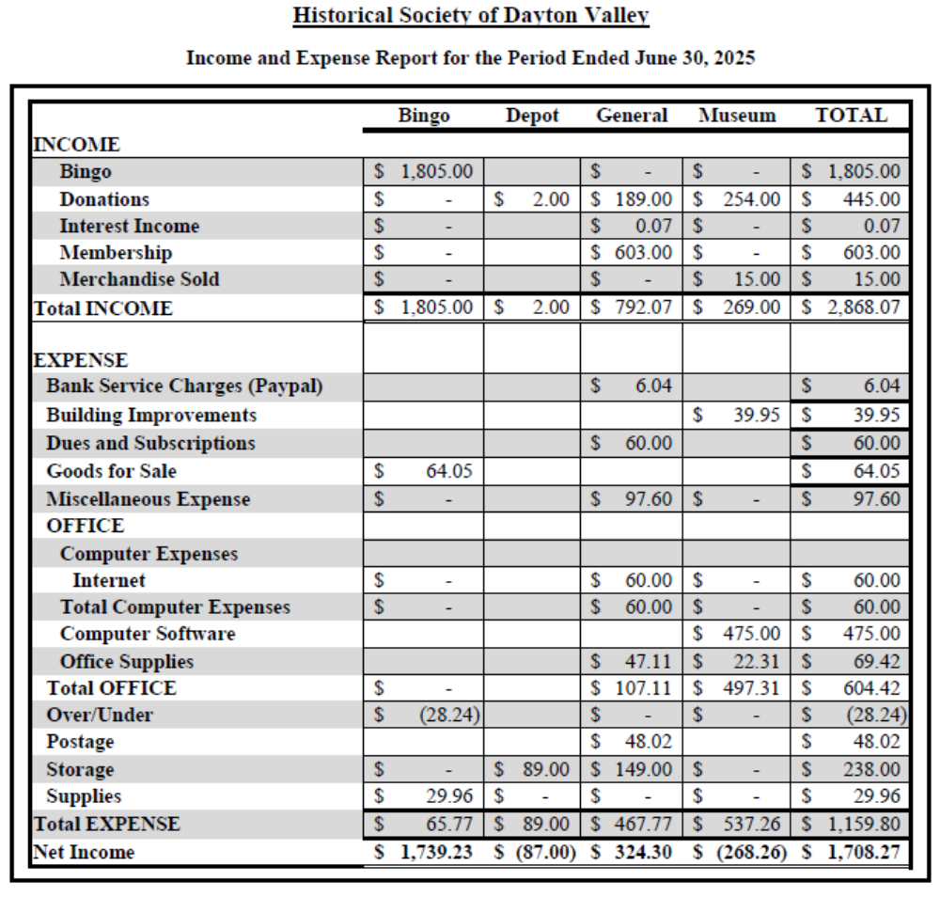
Attachment 1
Treasurer’s Reports (Page 2 of 3)

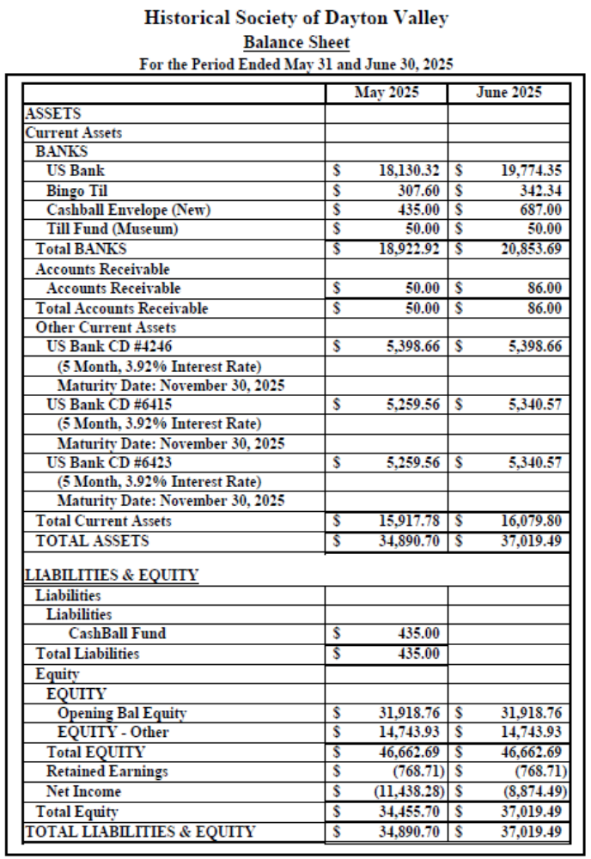

Attachment 1
Treasurer’s Reports (Page 3 of 3)

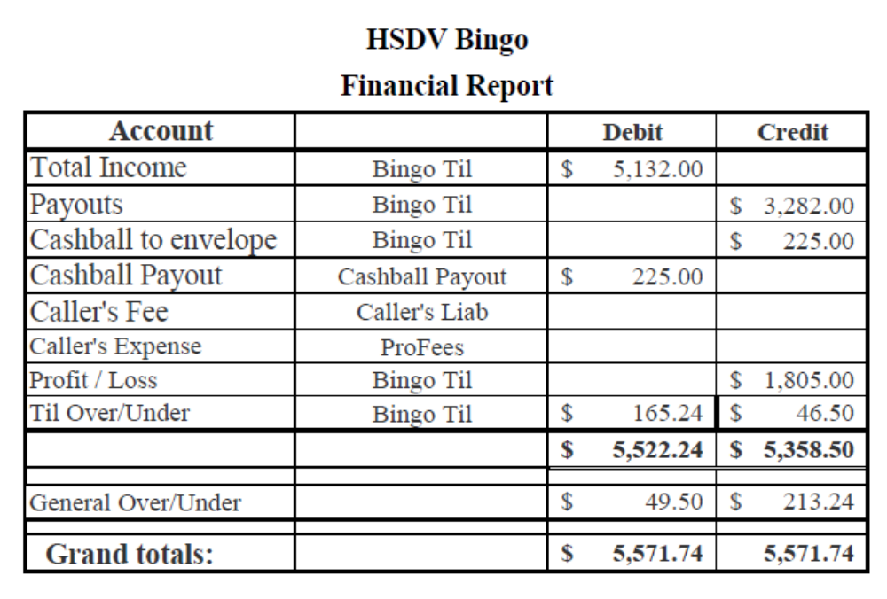

Attachment 2
Action Item List

# | Status | Month | Who | Item
2 | Open | Nov-23 | All / Linda/Becca | Possible future speakers for General Membership Meetings:  a) Fort Churchill Calvary Re-enactment Group (Becca)  b) Brenda Findley on key founders of VC (Becca)  c) Curator of History for Nevada Railroad Museum  d) Lady to talk about the Hippie era. (Linda)  e) Linda wants to do a cemetery tour, including "creepy" stories about people buried there. (Linda)  f) Linda has some other movies we could show. (Linda)  g) Linda - talk on the co-dependence and economic impact of Dayton's railroads and mills (Linda)  h) “The Technology of 19th-Century Dayton: How mills and railroads brought prosperity” (Linda)  k) For April or May, have a presentation by the people who do the living histories for the school programs. This might spur more members to volunteer (Vicki)  Doors open at 6:30 for socializing; Short business meeting is held at 7 followed by the lecture.  July: Tour of Bucklands (Laura to arrange, on Saturday, 7/19.) We have the bell from their school which we could present to them at that time.  Aug: “Carson & Colorado: Mound House to Hawthorne” by Lawrence Meeker  Sept: No lecture; Advertise "Come to DVD instead"; Linda to put together a flyer and Becca to post and advertise  Oct: No lecture; Advertise "Come to Historic Hayride instead
9 | On Hold Until Fall | Jan-24 | Becca | Create an online store on the website to sell mugs, books, calendars of historic photos, etc.

# | Status | Month | Who | Item
26 | On Hold Until Spring | Feb-24 | Linda | Draft a formal paper about the use of the speeder car by the Society, including a statement regarding insurance.  May-24: Linda put together an outline, and Lynne is happy with it.
28 | On Hold Until Spring | Feb-24 | Linda | Mark the cistern on the St. Ann's property and acknowledge the history of them.  Jun-24: We should get an engraved brass plaque made showing where it is and a brief history. It should have our logo on the top and a plaque number. We should do these everywhere in the town that we can. (Linda looking into where we can get the plaque made.)  May-25: Glenn got quotes from foundries but very expensive. Linda to investigate if she can 3D print them. Although that won't hold up as well, it might be cost effective.  Jun-25: Linda wants to get the right words for 1 plaque from Stony to make up as a trial.
30 | On Hold Until Depot Grd Breaking | Feb-24 | Linda/Dan/ Becca/Glenn/ Dave/Vicki/ Laura | Plan a party on the depot site when we have a ground breaking and another when we complete building; or even before a groundbreaking to raise funds for things not covered by insurance
53 | On Hold Until July | Apr-24 | Becca | Investigate a grant to get museum paintings restored.  Jun-24: It was suggested Laura contact the Nevada Arts Council.  Jul-24: Gloria found a YouTube video on how to clean old paintings. She will send it to Becca. It was also suggested we contact UNR to see if a student might clean our paintings as training. Becca may try to clean a painting if necessary but we need to identify a low-risk painting to start with.  Aug-24: Opened new action item 104 to separately track contacting NV Arts Council.  Sep-24: Becca researched methods and agreed to try on a small, least important painting (to be id'ed by Laura). She will purchase her own supplies (~$250) and if successful, will ask to be reimbursed.

# | Status | Month | Who | Item
61 | Open | May-24 | Glenn | Need to try to get new carpet for the museum at both the front office and the entry room. Perhaps a remnant or donation.  Jun-24: Gloria to measure the space.  Jul-24: Vicki has a bunch of people working on moving stuff for the chapel. She will ask them to measure it and work at getting carpet.  Aug-24: Measurements taken. Vicki to contact Atkins  Oct-24: Stony has some carpet but needs to see if it is enough.  Nov-24: The carpet is big enough. It is indoor/outdoor type. Stony and Glenn to arrange a work day after the museum is closed for the winter.  Mar-24: Laura will get the carpet to the museum. Glenn will lay the carpet using tacks (not glue).  Apr-25: Glenn still waiting on carpet.  May-25: The proposed carpet is not attractive. Laura will check with Atkins for what they have. Glenn will investigate what is currently in the museum.  Jul-25: Office needs carpet worse than entry room but ideally would like to replace both. Glenn will see what local stores have available.
68 | Open | May-24 | Glenn | Get display cabinets repaired for St. Ann's.  Jun-24: Once we move the pews and church stuff into the chapel, we will focus on repairing 1 cabinet at a time, working in the storage space.  Jul-24: Vicki and team are working on this.  Aug-24: Cabinet repairs expected to be completed before DVD. Pews have been moved back in.  Sep-24: 1st cabinet is completed. Remaining cabinets need to be evaluated if we need them and if they can be repaired.  Nov-24: Vicki is working on this.  Apr-25: Linda wants to see the display cabinets currently being stored at Sutro Self Storage. Decisions need to be reached if they are restorable, or if they are beyond repair.  May-25: There are only 3 cabinets left and they are questionable if they are worth repairing. Linda will look at them so we can decide how to proceed in June. If we want to keep them, they need to be moved to a cheaper storage unit.  Jul-25: Glenn will disassemble remaining cabinets and put the parts in the shed at the museum.
# | Status | Month | Who | Item
75 | On Hold Until Deport is Rebuilt | Jun-24 | Stony/Glenn / Laura | Talk to Phil Hanna and helpers about putting some doors on the carport at the depot so we can lock it up.  Jul-24: Motion passed to spend up to $500 to complete this effort.  Nov-24: This is a 2 day project. Glenn might be able to help. Stony has not seen any signs of trespassers lately.  Feb-25: Waiting on Stony to initiate action.  Jun-25: Laura needs to check if Stony still wants to do this.  Jul-25: Still should plan to do this after the depot is rebuilt.
78 | Open | Jun-24 | Stony/Laura | Add security to JohnD’s barn/shop.  Jul-24: Linda had an idea on security lights and camera which are motion activated. Stony would put it inside the shop. Motion passed for Linda to buy this. Stony agreed to install it.  Aug-24: Equipment has been purchased and is awaiting installation.  Oct-24: In process, but camera needs to be located  Jan-25: Stony has located the camera and will do the install.  Apr-25: Email reminder to be sent to Laura regarding Stony’s installation of camera at John D’s Barn/Shop.  May-25: Becca will remind Laura to remind Stony.  Jun-25: Stony is missing a component but is working on it.
102 | Open | Aug-24 | Linda | Finish the paperwork for the transfer of the Station Masters House. Linda has a contact to research the process. (Separated from Action Item 5)  Sep-24: The attorney is Steve Landuyt who is a member. Linda to ping him.  Nov-24: Linda has pinged him but no response yet.  Feb-25: Steve is working on it.  Mar-25: No reply from Steve yet.  Apr-25: Linda has not heard back from Steve Landuyt. It was recommended she find a real estate attorney and pay for their advice.  May-25: Linda is reaching out in a couple of directions.  Jun-25: The new Comstock Commissioner has legal training but isn't certified. She will review the papers once Linda puts them together.  Jul-25: Linda received very general feedback and is considering the next steps.
# | Status | Month | Who | Item
104 | On Hold Until Action Item 53 is worked | Aug-24 | Laura | Investigate a grant to get museum paintings restored through the Nevada Arts Council. (Separated from Action Item 53)  Nov-24: On hold until progress is made on action item 53.
134 | Open | Oct-24 | Linda | Make pamphlets for the firehouse/jail (if we don't already have one) and for the schoolhouse museum, including the history of the sites.  Nov-24: Laura to give a firehouse pamphlet to Linda.  Mar-25: Laura gave the pamphlet to Linda who is working on updating it. Also, Stony needs to give the key to the firehouse basement to Dave.  May-25: Key and lock to the firehouse basement given to Dave.  Jun-25: Linda is working on the pamphlets
138 | On Hold Until 2026 | Oct-24 | Becca | Arrange membership tour of Dangberg Home Ranch for the spring.  Feb-25: Postpone tour until June or July.  May-25: Guided house tours can be arranged Weds-Sun cost $10/person. Large group discount being investigated by Becca. Park grounds are public with picnic areas. Decided to arrange guided tour for a Saturday in July, preferably in the afternoon. Folks will provide their own transportation but we will provide directions.  Jun-25: Tours are temporarily suspended. Becca will monitor to see if we can do this at some time in the future.  Jul-25: Tours have resumed but they stop in Sept for the winter. Becca will contact them in 2026 to set a date after they resume in Mid-April.
156 | Open | Feb-25 | Glenn/Becca | Learn Past Perfect and its capabilities, especially in regards to an inventory system for items sold at the museum. (Spawned by action item 66.)
157 | Open | Feb-25 | Dan/Glenn | There is a nice display cabinet in the speeder shed that needs to be moved either to the chapel or the storage shed.  Feb-25: Dan, Glenn and Gene will move it.  May-25: It should be moved to the chapel.

# | Status | Month | Who | Item
159 | Open | Feb-25 | Linda/Dan/ Becca/Glenn/ Dave/Vicki/ Laura | Consider doing a “Day at the Rock Point” and a “Day at the Cemetery” outings.
162 | Open | Feb-25 | Linda/Dan/ Becca/Glenn/ Dave/Vicki/ Laura | We need more signage at the Rock Point
163 | Open | Feb-25 | Dan / Linda | Investigate getting a QR code for all our sites.  May-25: Dan is working at making the walking tour file smaller. Once on the website, the QR codes become easy. The map can have clickable locations as well. Voice files will be created in addition to the text.  Jun-25: Linda will send the file of just the map text to Dan.
166 | Open | Feb-25 | Laura | Assemble old hard copies of Laura's Reflections.  Mar-25: Laura has them and needs to get them to Dan to be scanned.  May-25: They are already on Newspapers.com which required a subscription; however, they are poorly scanned. Dan to talk to a librarian at the State Archives for ideas/methods.
167 | On Hold | Feb-25 | Dan | Investigate a large scanner to convert Laura's Reflections to digital format (among other items).  Mar-25: On hold until we discover if they are already digitally available somewhere.  Jun-25: On hold until we determine if there is a copier we can use periodically.
175 | Open | Apr-25 | Linda/Dan/ Becca/Glenn/ Dave/Vicki/ Laura | Could we rebuild the 2-story outhouse somewhere?  May-25: Can we do it like a barn raising?
176 | Open | Apr-25 | Laura | Restore ledger kept by Dr. Hazlett  Jun-25: The ledger is going to Joe Curtis to be restored.
179 | Open | Apr-25 | Glenn | Need to verify email is possible from Past Perfect to members; send out email and ask members to respond on receipt.
181 | Open | May-25 | Glenn/Margie | Plan for an ice cream social on the depot lot along with running the speeder, docents doing walking tour, fund raiser

# | Status | Month | Who | Item
182 | Open | May-25 | Glenn/Vicki | Make a path in the gravel in the yard at the museum handicap accessible around the edges  Jul-25: Will work in conjunction with work party for general clean-up which is Action Item 209. Motion: Authorize up to $250 for materials -- Passed (Motion: Linda; Second: Becca)
183 | Open | May-25 | Glenn | Propose a plan for landscaping at the Chapel.  Jul-25: Waiting on Design Standards Committee to make a recommendation
184 | Open | May-25 | Glenn/Dave/Dan/Vicki | New committee created to make recommendation to board on put up the entry way to the chapel  Jul-25: Waiting on the Chapel Committee to get with the Design Standards Committee to make a recommendation
188 | Open | May-25 | Glenn/Linda | Update signatories on the bank account to remove Gloria and add Linda  Jul-25: Gloria has been removed. Linda still needs to be added.
190 | On Hold Until Mar-2026 | May-25 | Vicki | Reorder school program so that Chautauqua is at the beginning.
191 | On Hold Until Nov 2025 | May-25 | Vicki | Write an article for the newsletter regarding the school program.  Jul-25: Suggested for January Newsletter to perhaps inspire more people to take part.
193 | Open | May-25 | Linda/Dan/ Becca/Glenn/ Dave/Vicki/ Laura | Move needed files on the museum PC from "Old Computer" file to appropriate place.
195 | Closed Jul-25 | May-25 | Becca | Coordinate volunteer appreciation cook-out for June 29th, including booking community center, invitation, awards, and food  Jun-25: Community Center is reserved. Invitations have been sent. There might be tablecloths at the museum to use for the tables.

# | Status | Month | Who | Item
197 | On Hold Until Mar-2026 | May-25 | Dave | Contact the Pony Express Re-Ride so that the stop in Dayton is a bigger part of the event.
198 | Open | Jun-25 | Laura | Laura would like another small cabinet for the museum near the Chinese stuff. She will send out desired dimensions.
199 | Closed Jul-25 | Jun-25 | Becca | Becca to email the pdf of the depot site plan to the board.
200 | Open | Jun-25 | Dan | Create a QR code to post at the museum that sends people to the membership page of the website. Becca to send him the page link once she re-enables the online memberships.  Jul-25: Becca has re-enabled online memberships and sent link to Dan the day before the BoD meeting
201 | Open | Jun-25 | Linda/Dan/ Becca/Glenn/ Dave/Vicki/ Laura | Make a coloring book for kids with pictures of Dayton buildings and a simple map.
202 | Open | Jun-25 | Dan | Investigate 3D grants through Travel Nevada and consider submitting an application.  Jul-25: Dan to meet with Travel Nevada people on 7/10.
203 | Closed Jul-25 | Jun-25 | Dan / Linda | Dan to select a date for a "Depot Cleanup". Linda will request the RR people come to help.  Jul-25: Only 1 stump remains to be removed, so no need for an overall depot clean up
204 | Open | Jun-25 | Becca | Submit a grant under the "250th Anniversary of Declaration of Independence" project to get diaries transcribed and published – part of the Public Scholar category. Anyone interested is handling the grant can contact Linda or Becca for information.  Jul-25: Becca to send info to the membership for people who might be interested in writing grants.
205 | Open | Jun-25 | Linda/Dan/ Becca/Glenn/ Dave/Vicki/ Laura | Send names of people who might be candidates for oral histories in the UNR "Shared History" project to Linda and Laura.  Jul-25: Gloria is setting up a schedule for this.
206 | Open | Jun-25 | Linda | Prepare annual report owed to the County on planned improvements/repairs. Laura to provide her a list of desired improvements at the museum.
# | Status | Month | Who | Item
207 | Open | Jun-25 | Linda/Dan/ Becca/Glenn/ Dave/Vicki/ Laura | Send Linda a list of anything needed by any of our buildings in way of maintenance, repairs, or improvements.
208 | Closed Jul-25 | Jun-25 | All | Get county to replace the outside electrical box at the museum which contains fuses and cobwebs.  Jul-25: Electrical box is not connected.
209 | Open | Jul-25 | Glenn/Vicki / Becca | Need a work party day to clean out weeds, dead-head plants and get the county to adjust watering.  Jul-25: Glenn and Vicki to organize for Friday 7/18 at 6 am. Becca to send notice about work party to members once Vicki sends her a write-up. Note: John Cassenelli was supposed to meet with Laura about the water but didn't show.
210 | On Hold Until Mar-2026 | Jul-25 | Becca | For volunteer appreciation luncheon, have name badges with what group they have worked with.
212 | Open | Jul-25 | Becca | Becca to resend Buckland Tour announcement and stress the need to RSVP.
213 | Open | Jul-25 | Linda/Dan/ Becca/Glenn/ Dave/Vicki/ Laura | Can we get the dirt pile behind the chapel moved and rent that space for parking during DVD?
214 | Open | Jul-25 | Glenn / Margie | Recommend the newsletter include a list of memorial notifications and a “welcome” to new members.
215 | Open | Jul-25 | Glenn / Margie | Recommend each newsletter include an article of “Member Highlight”, interviewing one member

Attachment 3
Committee List

Historical Society of Dayton Valley
DATE: 6 July 2025
FROM: Linda L. Clements, President
TO: HSDV Board (and other interested HSDV members)
SUBJECT: HSDV standing committees

In the past we’ve designated certain committees as Standing Committees and others as Ad-Hoc Committees. Standing committee support on-going projects while Ad-Hoc committees are formed to take care of a single event or other function.
It has been pointed out that some of our usual HSDV standing committees have not had chairs and/or a full complement of members who are willing to serve. In most cases a committee should have a chair and members and not constitute a “committee of one.” However, in some cases when activity levels are light or committee members scarce the Board may act as the “sounding board” for a single committee member/chair. (I’m thinking Firehouse/Jail….)
Below are some of our standing committees, but feel free to add any I’ve forgotten. Please help me fill in and/or correct committee chairs, members, etc. Also, in some cases there may be folks who want to join a committee that have not been asked.
Note that this is not fixed in stone; we may want to change some of these, add different designations (i.e., standing or not; NO, not “sitting!”), etc.
Standing Program Committees:
- RR Committee – [dormant for lack of chair…and a depot]
  - Depot Rebuilding Subcommittee – Stony, Linda, John
  - RR Operations Subcommittee – Dan South, chair;
- Bingo – Glenn Sidener, chair;
- Museum – Laura Tennant, chair;
  - Accessioning – Laura Tennant, chair;
  - Docent – ?Laura Tennant, chair;
  - Gift Shop –
- Firehouse/Jail – Dave Schmitt, chair;
- Chapel –
Standing Service Committees:
- Publicity – Laura, Linda, Becca, …
- School/Education Program – Vicki Kinney, chair;
- Membership – Vicki Kinney, chair;
Attachment 3 (Cont’)
Committee List (Cont’)

- Elections – Becca Krach, chair;
- Hospitality –
- Arrangements (audio/video, tables, reserve room, etc.) –
- Audits – Gene Kinney & Patrick Neylan
- Design Standards – Stony, chair; Dave Schmitt,
- Buildings and Grounds Maintenance (watering, etc.) –
- Monthly Lectures & Events – Linda Clements, chair; Laura Tennant,
- Others? [i.e., Purchasing (supplies)??]
The following Ad-Hoc committees are aimed at a single event but that event happens every year, so I list them here.
- Hayride –
- Holiday Awards Party –

Committee decisions are made by the committee as a whole, not solely by the chair. Major decisions need to come to the Board for approval but the committee is authorized to make non-major decisions. [Note, a major decision is one that makes a significant change to current procedures and/or with a financial impact of $150 or more. This $150 limit may be increased by vote of the Board for specific committees or activities.]
Certain committees, such as Bingo or the Railroad Committee, may be granted additional autonomy by the Board, either for a short-term project or for a longer period.
Note: Please critique what I’ve outlined above, including about decisions, suggest additions or changes, etc., etc.

Attachment 4
Planning Calendar

Month | Activity
Jan | Plan for Museum Opening
Jan | Collect information of who volunteered the prior year
March | Opening of Museum
March | Mail invitations for Volunteer Appreciation Luncheon
March | Prepare and file IRS taxes
April | Hold Volunteer Appreciation Luncheon
April | Plan the 4th grade school program
May | Conduct 4th grade school program
May | Start work on membership renewals due June 30th
July | Plan for Dayton Valley Days
August | Notify membership about elections procedures and nominations
August | Plan for Historic Hayride
August | Submit application for DVD booth
Sept | Open nominations for elections
Sept | Dayton Valley Days
Sept | Start reviewing insurance renewals
Oct | Mail out ballots for elections
Oct | Hold Historic Hayride
Oct | Board to vote on any awards to be given
Oct | Plan for Holiday Party
Nov | Complete elections vote counting
Nov | Send out invitations for Holiday Party
Nov | Ensure community center is reserved for next year's BoD mtgs and monthly membership mtgs
Dec | Holiday Party

Attachment 5
Elections Calendar

When | Day of the Week | 2025 dates | Who | What
August Newsletter | -- | 8/15 | Secretary | Provide nomination info to newsletter editor (Optional if there is a newsletter in this time period)
Mid-August | -- | 8/15 | Secretary | Mail nomination info to all members
Sept BoD Mtg | Weds | 9/10 | -- | Nominations Open
From Sept BoD Mtg until Monday after Oct Bod Mtg | -- | 9/10 - 10/13 | Secretary | Candidates are contacted to ensure they are willing to serve. Candidates must provide 1 paragraph election statement by the end of this time period
Oct BoD Mtg | Weds | 10/8 | -- | Nominations Close
30 days before Nov General Membership Mtg | Tues | 10/21 | Member-ship Chairman | Membership Chairman is to make an official copy of members in good standing on this date. Only they can vote.
Wednesday, 4 weeks prior to Nov General Membership Mtg | Weds | 10/22 | Secretary | Deadline for mailing out the voting packets to all members in good standing.
Monday prior to Nov General Membership Mtg | Mon | 11/17 | -- | HSDV must receive completed ballots in the mail by this date.
Tuesday prior to Nov General Membership Mtg | Tues | 11/18 | Treasurer | Pick up mail from the PO Box on Tuesday.
Nov General Membership Mtg | Thurs | 11/20 | Members | Members vote in person at the general membership meeting by bringing sealed, "mail ready" ballot envelopes to the meeting.

Attachment 5 (Cont’)
Elections Calendar (Cont’)

When | Day of the Week | 2025 dates | Who | What
Nov General Membership Mtg | Thurs | 11/20 | Election Panel | Ballots to be processed only by Election Panel.  o Verify ballots are from members on the official “good standing” membership list and only 1 ballot per person received, whether by mail or in person.  o Ballots are removed from the envelopes thus separating the votes from the voter names.  o Ballots are counted and results are announced.  o In the event of a tie, it is broken by an additional vote of members present at Nov General Membership Meeting
Tuesday after the Nov General Membership Mtg | Tues | 11/25 | Secretary | Results are sent to all members in good standing by this date

