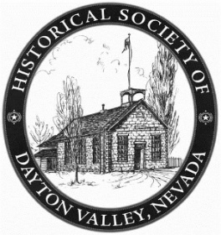
historical society of dayton valley
August 13, 2025
1:00 pm – At DVCC

Board meetings are directed towards “Board Business”. Members may audit these meetings but asked to refrain from making comments or asking questions until the board has completed their discussion of the topic; however, by advanced request, a member may ask to be placed on Board Agendas for a special reason.

In the absence of both the Secretary, Becca, and the Vice President, Dan, the Treasurer, Glenn, took minutes.

CALL MEETING TO ORDER – President, Linda Clements, called BoD meeting to order at 1:38 pm.

BOARD MEMBERS PRESENT:

Position | Name | Present (√)
President | Linda Clements | √
Vice President | Dan South
Secretary | Becca Krach
Treasurer | Glenn Sidener | √
Director 1 | Dave Schmitt | √
Director 2 | Vicki Kinney | √
HSDV Historian (Ex Officio) | Laura Tennant | √
Guest | Stony Tennant | √

Approval of Agenda skipped due to lack of Agenda availability. (John Crowley brought copies early in the meeting.)

Copies of the previous minutes were not available so approval of July 9th Board Meeting minutes was also skipped.

Treasurer’s Report: (See Attachment 1) Because Glenn is responsible for both, the Bingo report was moved to be under the Treasurer’s report. Bingo Report showed $2,780 in profits for July, with $279.70 spent on bingo paper and supplies. Large donations received for the Lisa Smith Memoriam totaling $4,825.80. Membership renewals total $1,040 for July. Explanation of expenses given, including a negative expense under Misc Expenses. Request was made to purchase a new register for Bingo, with photo and description of desired register passed around to board. Motion to allow purchase of register made by Glenn, seconded by David. Motion approved.
Motion to Approve Treasurer’s Report made by Vicki, seconded by David. Motion approved.

President’s Comments: With so much to do, not much to say.

Board member comments: David asked Laura for Museum Keys. Laura will get keys to all who request one. David brought up the showing of the Fire Truck during DVD, and the need to keep kids and visitors off of the truck for pictures. The truck is too old for any person, young or old, to be climbing on it. It was requested that we make a sign to keep everyone off. The Bell at the firehouse is small and the rope breaks easy, so it is to be rung only when supervised by a docent familiar with the rope. Discussion exposed that the rope is in direct sunlight (UV exposure) and that Dave should get UV repellant rope so the rope will last longer, and submit expense report for item to Glenn.

Old Business:
1) Action Item List addressed as needed (See Attachment 2)

2) Depot Committee: Email rec’d from Lyon Count Comptroller Josh Foli confirming that rebuilding the depot will once again be on the Commissioners agenda on Aug 21st in Yerington. Stony had sent out letter to keep questions down about no power or water at the initial rebuild. Those items in question are not covered by insurance, and will be addressed later. Linda will prepare an email to distribute to all members asking for emails from them in support of depot rebuild and will send it to Glenn for distribution.

3) Bingo report moved to Treasurer’s report

4) Buckland Tour (Vicki): David went to the tour and will send pictures to board members. Vicki was happy with the turnout.

5) Main Street, Nevada (Dan): Dan was not present and this is deferred to the next meeting.

6) DVD plans: We may need someone to help run the railroad booth this year. John may not be capable this year. Various volunteers were mentioned to help with the booth, including Janet Stepper, Phil Hanna, Jerry Van Loo, and others. Mel and Dave Cooper have expressed desire to help. David is at the Fire House, so we need docents to cover his spot in the museum during DVD. Linda suggested Laura contact Chamber directly to talk about better access to museum after last year’s fiasco of blocking the streets for vendors.

7) Long Range plan for Society (Linda): Looking for chair for chapel; Vicki suggested we get committee together and pick a chair. Glenn and David to check on water system implementation at the chapel. Stoney knows where the water shutoff is to be able to add in water supply “Tee” to existing water supply.

New Business:
1) Historic Hayride: Janet Steeper had ideas to make the hayride better. Linda and others will contact her for her ideas. Usual date of hayride falls on Halloween, and past hayrides on Halloween have been very low attendance. Decision made to hold hayride on different date. Lots of good response on hayride last year per Vicki. Thursday, Oct 30th was decided on, since Halloween is a no-go. Oct 31 is Nevada day, so there is no school on 31st. Looking for drivers. Lack of barricades and county support was an issue for last year’s hayride. Board members will contact Janet to see if she will help us this year. Need a debriefing after the hayride for ideas that worked and those that didn’t.

2) Policy on emails to other organizations: Becca suggested that we send out information once a month for other orgs. Linda moved that we send out these emails at the most once a month, and David seconded. Motion approved.

3) Vicki moved that Lee Vecchiarelli be given an honorary membership. Laura seconded. Motion approved.

4) Linda reported that the GoFundMe account that Lynne Ballatore set up after the depot fire cannot be accessed at this time, since no single person has the password and access to the email and phone number. We cannot thank donors until Linda and Lynne get it under Linda’s control. We also need to find out if previous donations have been transferred to us or if the money is being held and, if so, how much is in that account.

5) History Moment (Laura): Next time! (There were too many other things going on this month.)

Meeting adjourned 3:20pm.

Respectfully submitted: Glenn Sidener, Treasurer
Approved by the Board: September 10, 2025

Attachment 1
Treasurer’s Report

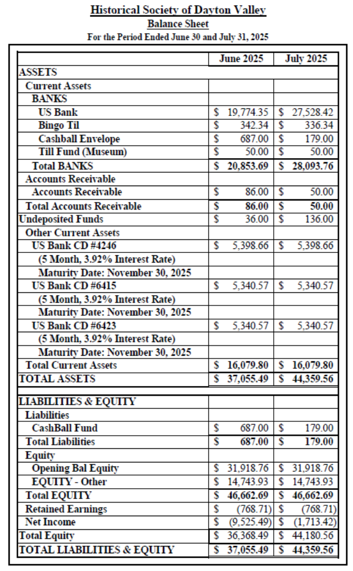

Attachment 1 (Cont’)
Treasurer’s Report

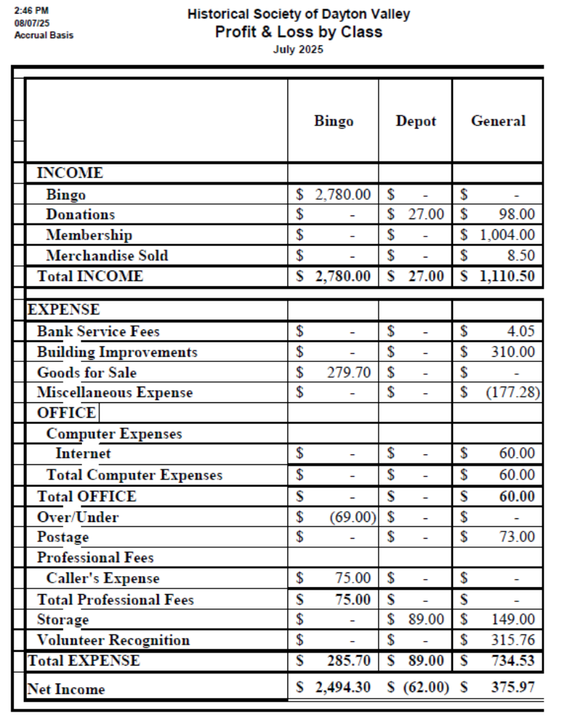

Attachment 1 (Cont’)
Treasurer’s Report

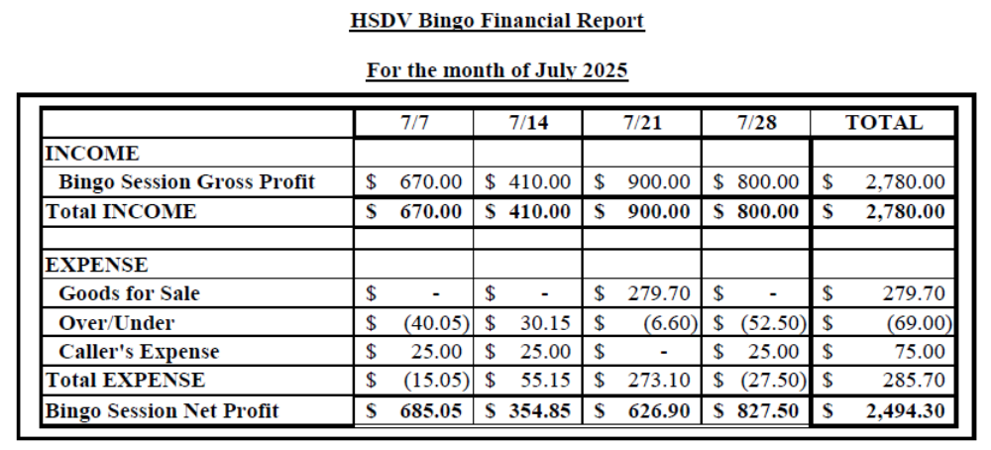

Attachment 2
Action Item List

# | Status | Month | Who | Item
2 | Open | Nov-23 | All / Linda/Becca | Possible future speakers for General Membership Meetings:  a) Fort Churchill Calvary Re-enactment Group (Becca)  b) Brenda Findley on key founders of VC (Becca)  c) Curator of History for Nevada Railroad Museum  d) Lady to talk about the Hippie era. (Linda)  e) Linda wants to do a cemetery tour, including "creepy" stories about people buried there. (Linda)  f) Linda has some other movies we could show. (Linda)  g) Linda - talk on the co-dependence and economic impact of Dayton's railroads and mills (Linda)  h) “The Technology of 19th-Century Dayton: How mills and railroads brought prosperity” (Linda)  k) For April or May, have a presentation by the people who do the living histories for the school programs. This might spur more members to volunteer (Vicki)  Doors open at 6:30 for socializing; Short business meeting is held at 7 followed by the lecture.  July: Tour of Bucklands (Laura to arrange, on Saturday, 7/19.) We have the bell from their school which we could present to them at that time.  Aug: “Carson & Colorado: Mound House to Hawthorne” by Lawrence Meeker  Sept: No lecture; Advertise "Come to DVD instead"; Linda to put together a flyer and Becca to post and advertise  Oct: No lecture; Advertise "Come to Historic Hayride instead
9 | On Hold Until Fall | Jan-24 | Becca | Create an online store on the website to sell mugs, books, calendars of historic photos, etc.
30 | On Hold Until Depot Grd Breaking | Feb-24 | Linda/Dan/ Becca/Glenn/ Dave/Vicki/ Laura | Plan a party on the depot site when we have a ground breaking and another when we complete building; or even before a groundbreaking to raise funds for things not covered by insurance
53 | On Hold Until July | Apr-24 | Becca | Investigate a grant to get museum paintings restored.  Jun-24: It was suggested Laura contact the Nevada Arts Council.  Jul-24: Gloria found a YouTube video on how to clean old paintings. She will send it to Becca. It was also suggested we contact UNR to see if a student might clean our paintings as training. Becca may try to clean a painting if necessary but we need to identify a low-risk painting to start with.  Aug-24: Opened new action item 104 to separately track contacting NV Arts Council.  Sep-24: Becca researched methods and agreed to try on a small, least important painting (to be id'ed by Laura). She will purchase her own supplies (~$250) and if successful, will ask to be reimbursed.  July 25: Ruth Small has volunteered to repair paintings. Vicki suggested we talk with Ruth and Becca about the work before implemented.
138 | On Hold Until 2026 | Oct-24 | Becca | Arrange membership tour of Dangberg Home Ranch for the spring.  Feb-25: Postpone tour until June or July.  May-25: Guided house tours can be arranged Weds-Sun cost $10/person. Large group discount being investigated by Becca. Park grounds are public with picnic areas. Decided to arrange guided tour for a Saturday in July, preferably in the afternoon. Folks will provide their own transportation but we will provide directions.  Jun-25: Tours are temporarily suspended. Becca will monitor to see if we can do this at some time in the future.  Jul-25: Tours have resumed but they stop in Sept for the winter. Becca will contact them in 2026 to set a date after they resume in Mid-April.
156 | Open | Feb-25 | Glenn/Becca | Learn Past Perfect and its capabilities, especially in regards to an inventory system for items sold at the museum. (Spawned by action item 66.)
159 | Open | Feb-25 | Linda/Dan/ Becca/Glenn/ Dave/Vicki/ Laura | Consider doing a “Day at the Rock Point” and a “Day at the Cemetery” outings. Aug 25: Need to complete before Sutro Tunnel completion to VC.
162 | Open | Feb-25 | Linda/Dan/ Becca/Glenn/ Dave/Vicki/ Laura | We need more signage at the Rock Point
175 | Open | Apr-25 | Linda/Dan/ Becca/Glenn/ Dave/Vicki/ Laura | Could we rebuild the 2-story outhouse somewhere?  May-25: Can we do it like a barn raising?
193 | Open | May-25 | Linda/Dan/ Becca/Glenn/ Dave/Vicki/ Laura | Move needed files on the museum PC from "Old Computer" file to appropriate place. Aug 25: Linda still needs to find the time to AnyDesk onto the Museum computer.
201 | Open | Jun-25 | Linda/Dan/ Becca/Glenn/ Dave/Vicki/ Laura | Make a coloring book for kids with pictures of Dayton buildings and a simple map.
204 | Closed | Jun-25 | Becca | Submit a grant under the "250th Anniversary of Declaration of Independence" project to get diaries transcribed and published – part of the Public Scholar category. Anyone interested is handling the grant can contact Linda or Becca for information.  Jul-25: Becca to send info to the membership for people who might be interested in writing grants.  Aug 25: Closed due to missing deadlines for most of this.
205 | Open | Jun-25 | Linda/Dan/ Becca/Glenn/ Dave/Vicki/ Laura | Send names of people who might be candidates for oral histories in the UNR "Shared History" project to Linda and Laura.  Jul-25: Gloria is setting up a schedule for this. Aug 25: Still looking for more candidates, those that have lived for a long time with Nevada-related stories.
207 | Open | Jun-25 | Linda/Dan/ Becca/Glenn/ Dave/Vicki/ Laura | Send Linda a list of anything needed by any of our buildings in way of maintenance, repairs, or improvements.  Aug 25: Glenn submitted a list of items to Linda. Vicki needs to send her input to Linda.
209 | Closed Aug-25 | Jul-25 | Glenn/Vicki / Becca | Need a work party day at museum to clean out weeds, dead-head plants and get the county to adjust watering.  Jul-25: Glenn and Vicki to organize for Friday 7/18 at 6 am. Becca to send notice about work party to members once Vicki sends her a write-up. Note: John Cassenelli was supposed to meet with Laura about the water but didn't show. Aug 25: Work completed by Vicki, Gene, Stony, and Glenn.
210 | On Hold Until Mar-2026 | Jul-25 | Becca | For volunteer appreciation luncheon, have name badges with what group they have worked with.
212 | Closed Aug-25 | Jul-25 | Becca | Becca to resend Buckland Tour announcement and stress the need to RSVP.
213 | Open | Jul-25 | Linda/Dan/ Becca/Glenn/ Dave/Vicki/ Laura | Can we get the dirt pile behind the chapel moved, install posts and chain to keep out unwanted parkers, and rent that space for parking during DVD? Aug 25: Get with Stony to use his tractor and move dirt behind Fire House.

216 | Open | Jul-25 | Becca | Correlate information regarding the Dayton Cemetery and structure a cemetary documentation project.  Aug 25: Becca and Linda working on it.

