historical society of dayton valley
September 10, 2025
1:00 pm – At DVCC

Board meetings are for Board Business. Members are welcome to attend and can comment if invited to do so by the chair or after the board has finished their discussion, but remarks should be limited so that the Board agenda can be completed. By advanced request, a member may ask to be placed on the Board Agenda to offer specific information or request a specific action.

CALL MEETING TO ORDER – President, Linda Clements, called BoD meeting to order at 1:07 pm.

BOARD MEMBERS PRESENT:

Position | Name | Present (√)
President | Linda Clements | √
Vice President | Dan South | √
Secretary | Becca Krach | √
Treasurer | Glenn Sidener | √
Director 1 | Dave Schmitt | √
Director 2 | Vicki Kinney
Director 3
HSDV Historian (Ex Officio) | Laura Tennant | √
Guest | Stony Tennant | √

APPROVAL OF AGENDA –
- Agenda for September 10, 2025 was approved with the below additions. (Motion: Becca, Second: Dan) – Motion Passed
  - Closed session will be covered at the start of the meeting.
  - Add under New Business: Start reviewing insurance renewals

APPROVAL OF MINUTES –
- Minutes for July 9, 2025 (both regular session and closed session) were approved. (Motion: Glenn, Second: Dan) – Motion Passed
- Minutes for August 13, 2025 were approved. (Motion: Glenn, Second: Dan) – Motion Passed

TREASURER’S REPORT –
- Glenn presented the Balance Sheet, Page and Line, and Bingo Financial Reports for August 2025. (See Attachment 1).
- Motion: Approve the Treasurer’s Reports. (Motion: Becca, Second: Dan) -- Motion Passed

CORRESPONDENCE – Communications received:
- Received various monthly mailings from museums associations

PRESIDENT COMMENTS:
- None

BOARD MEMBER COMMENTS:
- Becca requested that Laura speak with Janette about getting keys to the community center for convenience.

HISTORY MOMENT (Laura):
- The society was created to preserve the Bluestone Building. It was in bad condition and the initial work of the society was to repair the building. The building is now the justice court. Laura talked about the people involved and how it got going, leading to the creation of the museum.

OLD BUSINESS
- Reviewing Action Item List – Everyone (See Attachment 2)
  - Action Item 102 -- Motion: Authorize Linda to spend up to $1000 to get a lawyer involved. (Motion: Dan; Second: Glenn) Motion Passed
  - Becca is to separate the open action item list into current actions and future ideas (“Aspirations”) in order to reduce the number of items discussed at each board meeting.
- Report: Depot Committee – Rebuild progress – Stony Tennant and/or John Crowley
  - No news despite Stony calling Josh just prior to the board meeting. We are still waiting on the date for the pre-construction conference.
  - It was noted that we have recourse to stop their final payment to the contractor if something is not done according to the specs.
  - Stan Paher is going to give us a large donation at DVD for the depot rebuilding.
  - Motion: Authorize Linda to spend up to $1500 to purchase hats and t-shirts to resell at DVD. (Motion: Dan; Second: Becca) Motion Passed
- Updates on Main Street Nevada project – Dan
  - They are in the process of submitting the first grant request through America 250, for next year, to clean up some of the downtown.
  - They are also working to narrow down the list of possible projects to 3, to work through Main Street Nevada.
- Dayton Valley Days, Sept. 20-21 – Linda & Board
  - We need signs on Pike Street pointing to the museum (sandwich board). Dan will take care of this.
  - Railroad/speeder is covered.
  - Firehouse – Dave is still waiting on response from Larry to help but Dave will be there regardless.
  - Booth outside Chapel – Covered by Glenn and Margie
  - Museum – Laura, Becca, and Katrina will cover this, as well as a few other potential people.
- Historic Hayride – Board … NEED CHAIR!!
  - Becca will schedule a meeting, including previous volunteers and take notes. The first item of business will be to see if someone is willing to chair the event, or if people think we can pull it off without a chair.
- Membership update – Vicki/Glenn
  - We have $2,266 for this year.

NEW BUSINESS
- Open nominations for elections – Becca
  - Terms are expiring for Linda (President), Glenn (Treasurer), Vicki (Director), and Dave (Director)
  - We also have 1 Director slot which is empty that could be filled for a 1 year term.
  - Linda and Glenn are willing to stand for re-election. Dave is undecided. Becca will check with Vicki.
  - No nominations have been received yet from the membership at large.
  - Nominations will close at the October Board Meeting.
- Update on GoFundMe
  - Donations are automatically transferred to our PayPal account.
- Sutro “Meat” and Drink, Sept. 11 – Glenn
  - Glenn, Margie, Lynne, Laura, and Stony will be going.
- Holiday Awards party – need chair!
  - Consider using the same caterer again. Glenn has the name of the caterer.
- Potential approval of purchases for collection – Linda
  - Deferred
- Should we consider offering to coordinate an annual cemetery cleanup? – Linda
  - This will be put on “Aspiration list”.
  - We should consider reaching out to an existing group that does cemetery maintenance for how this works.
  - Becca noted that there is a class “Working with Volunteers at Cemeteries” from the American Association for State and Local History (AASLH). She will consider if she can attend.
- Start reviewing insurance renewals
  - Glenn had investigated this. Out insurance is due in October for the same cost and same coverage. Glenn will renew.
- Planning calendar
  - The item for “Plan for Dayton Valley Days” should be moved from July to March.
  - Becca also noted that an item should be added for submitting the yearly bingo authorization to the gaming control board.
  - See Attachment 3 for revised calendar.

CLOSED SESSION (as needed, Board only, time TBD)
- Minutes for the closed session were circulated only to the board members and kept in the secretary’s files as the topic dealt with an issue with a member.
- Although the following motion was addressed during the closed session, it is applicable to all transactions for HSDV and does not contain any confidential information. Therefore, it is included here for the record.
  - Motion: All invoices need the treasurer and at least 1 other board member to agree they are legitimate before they can be accepted. (Motion: Dan; Second: Becca) Motion Passed and applicable to all transactions for HSDV.

UPCOMING ABSENCES:

Who | When | Comments
Vicki | Most of Sept.

NEXT BOARD MEETING: Wednesday, October 8, 2025

ADJOURN: Meeting formally adjourned at 4:12 pm.

Respectfully submitted: Becca Krach, Secretary
Approved by the Board: ___

BOARD OF DIRECTORS
President, Linda Clements 775-246-0505 – Vice President, Dan South 775-220-8021
Secretary, Becca Krach 443-799-4827 – Treasurer, Glenn Sidener 775-671-4205
Directors Vicki Kinney 775-750-7915, Dave Schmitt 408-802-8997
Dayton Historian & Curator – Laura Tennant 775-246-3256
Attachment 1
Treasurer’s Reports (Page 1 of 3)

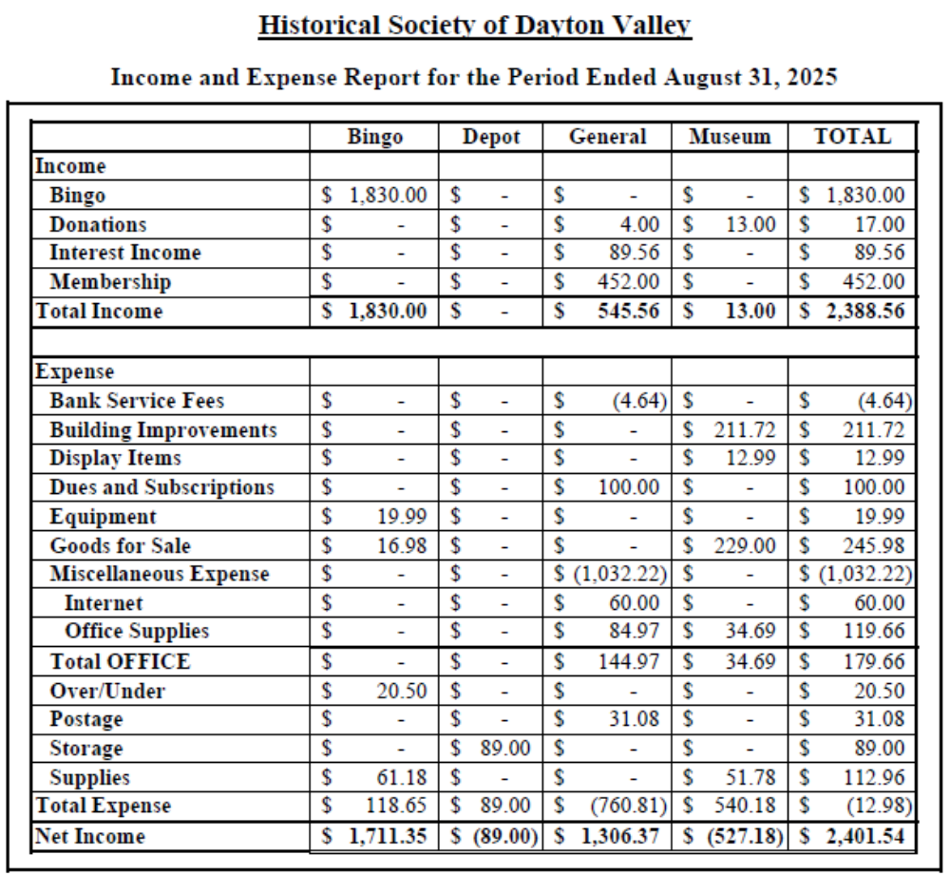
Attachment 1
Treasurer’s Reports (Page 2 of 3)

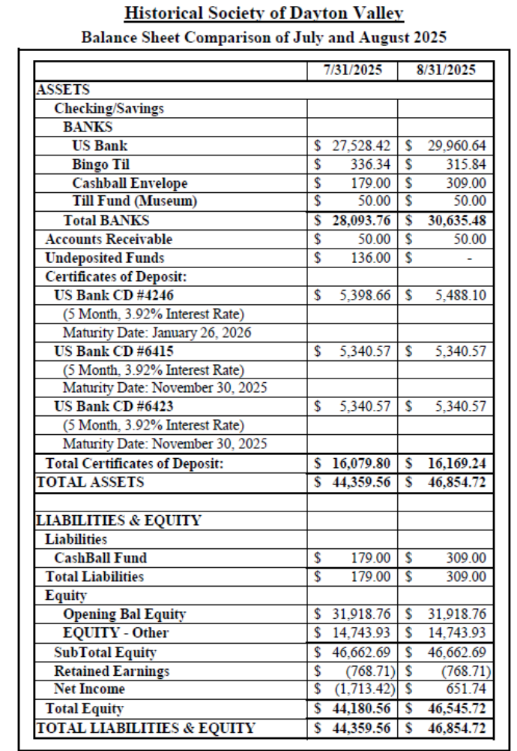

Attachment 1
Treasurer’s Reports (Page 3 of 3)

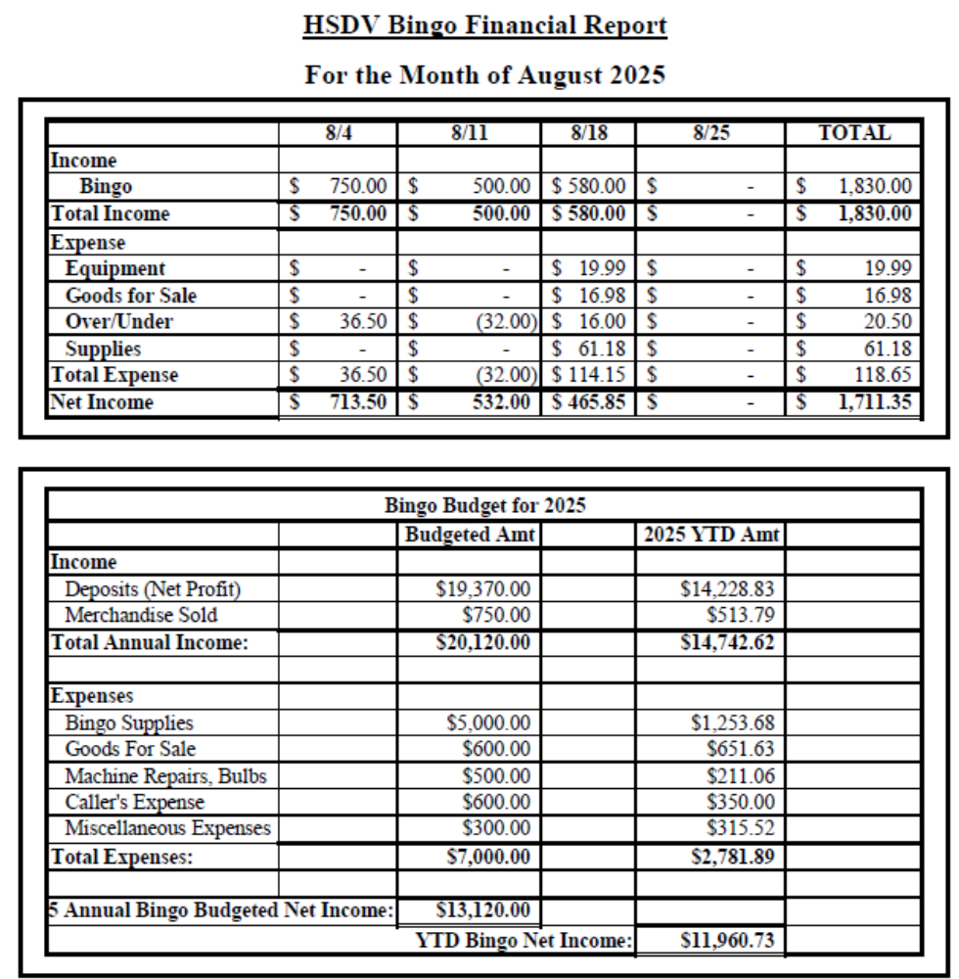
Attachment 2(a)
Action Item List

# | Status | Month | Who | Item
2 | Closed Sep-25 | Nov-23 | All / Linda/Becca | Possible future speakers for General Membership Meetings:  a) Fort Churchill Calvary Re-enactment Group (Becca)  b) Brenda Findley on key founders of VC (Becca)  c) Curator of History for Nevada Railroad Museum  d) Lady to talk about the Hippie era. (Linda)  e) Linda wants to do a cemetery tour, including "creepy" stories about people buried there. (Linda)  f) Linda has some other movies we could show. (Linda)  g) Linda - talk on the co-dependence and economic impact of Dayton's railroads and mills (Linda)  h) “The Technology of 19th-Century Dayton: How mills and railroads brought prosperity” (Linda)  k) For April or May, have a presentation by the people who do the living histories for the school programs. This might spur more members to volunteer (Vicki)  Doors open at 6:30 for socializing; Short business meeting is held at 7 followed by the lecture.  July: Tour of Bucklands (Laura to arrange, on Saturday, 7/19.) We have the bell from their school which we could present to them at that time.  Aug: “Carson & Colorado: Mound House to Hawthorne” by Lawrence Meeker  Sept: No lecture; Advertise "Come to DVD instead"; Linda to put together a flyer and Becca to post and advertise  Oct: No lecture; Advertise "Come to Historic Hayride instead  Nov: Linda is trying to get a railroad person  From now on, Linda will maintain a list of potential speakers and the agenda will include a standing item for the next month's lecture.
Action Item List (Cont’)

# | Status | Month | Who | Item
53 | Open | Apr-24 | Laura | Investigate a grant to get museum paintings restored.  Jun-24: It was suggested Laura contact the Nevada Arts Council.  Jul-24: Gloria found a YouTube video on how to clean old paintings. She will send it to Becca. It was also suggested we contact UNR to see if a student might clean our paintings as training. Becca may try to clean a painting if necessary but we need to identify a low-risk painting to start with.  Aug-24: Opened new action item 104 to separately track contacting NV Arts Council.  Sep-24: Becca researched methods and agreed to try on a small, least important painting (to be id'ed by Laura). She will purchase her own supplies (~$250) and if successful, will ask to be reimbursed.  Aug-25: Ruth Small has volunteered to repair paintings. Vicki suggested we talk with Ruth and Becca about the work before implemented.  Sep-25: Ruth has decided that soap and water is not a good idea. Becca is willing to donate the supplies she has. Laura is to coordinate this effort.
Action Item List (Cont’)

# | Status | Month | Who | Item
61 | Open | May-24 | Glenn | Need to try to get new carpet for the museum at both the front office and the entry room. Perhaps a remnant or donation.  Jun-24: Gloria to measure the space.  Jul-24: Vicki has a bunch of people working on moving stuff for the chapel. She will ask them to measure it and work at getting carpet.  Aug-24: Measurements taken. Vicki to contact Atkins  Oct-24: Stony has some carpet but needs to see if it is enough.  Nov-24: The carpet is big enough. It is indoor/outdoor type. Stony and Glenn to arrange a work day after the museum is closed for the winter.  Mar-24: Laura will get the carpet to the museum. Glenn will lay the carpet using tacks (not glue).  Apr-25: Glenn still waiting on carpet.  May-25: The proposed carpet is not attractive. Laura will check with Atkins for what they have. Glenn will investigate what is currently in the museum.  Jul-25: Office needs carpet worse than entry room but ideally would like to replace both. Glenn will see what local stores have available.  Sep-25: The new carpet has arrived. Glenn and Dave will install it on Saturday.

Action Item List (Cont’)

# | Status | Month | Who | Item
68 | Closed Sep-25 | May-24 | Glenn | Get display cabinets repaired for St. Ann's.  Jun-24: Once we move the pews and church stuff into the chapel, we will focus on repairing 1 cabinet at a time, working in the storage space.  Jul-24: Vicki and team are working on this.  Aug-24: Cabinet repairs expected to be completed before DVD. Pews have been moved back in.  Sep-24: 1st cabinet is completed. Remaining cabinets need to be evaluated if we need them and if they can be repaired.  Nov-24: Vicki is working on this.  Apr-25: Linda and others want to see the display cabinets currently being stored at Sutro Self Storage. Decisions need to be reached if they are restorable, or if they are beyond repair.  May-25: There are only 3 cabinets left and they are questionable if they are worth repairing. Linda will look at them so we can decide how to proceed in June. If we want to keep them, they need to be moved to a cheaper storage unit.  Jul-25: Glenn will disassemble remaining cabinets and put the parts in the shed at the museum.
78 | Open | Jun-24 | Stony/Laura | Add security to JohnD’s barn/shop.  Jul-24: Linda had an idea on security lights and camera which are motion activated. Stony would put it inside the shop. Motion passed for Linda to buy this. Stony agreed to install it.  Aug-24: Equipment has been purchased and is awaiting installation.  Oct-24: In process, but camera needs to be located  Jan-25: Stony has located the camera and will do the install.  Apr-25: Email reminder to be sent to Laura regarding Stony’s installation of camera at John D’s Barn/Shop.  May-25: Becca will remind Laura to remind Stony.  Jun-25: Stony is missing a component but is working on it.
Action Item List (Cont’)

# | Status | Month | Who | Item
102 | Open | Aug-24 | Linda | Finish the paperwork for the transfer of the Station Masters House. Linda has a contact to research the process. (Separated from Action Item 5)  Sep-24: The attorney is Steve Landuyt who is a member. Linda to ping him.  Nov-24: Linda has pinged him but no response yet.  Feb-25: Steve is working on it.  Mar-25: No reply from Steve yet.  Apr-25: Linda has not heard back from Steve Landuyt. It was recommended she find a real estate attorney and pay for their advice.  May-25: Linda is reaching out in a couple of directions.  Jun-25: The new Comstock Commissioner has legal training but isn't certified. She will review the papers once Linda puts them together.  Jul-25: Linda received very general feedback and is considering the next steps.  Sep-25: Linda will contact a lawyer and pay them to do the paperwork. Motion: Authorize Linda to spend up to $1000 to get a lawyer involved. (Motion: Dan; Second: Glenn) Motion Passed
134 | Open | Oct-24 | Linda | Make pamphlets for the firehouse/jail (if we don't already have one) and for the schoolhouse museum, including the history of the sites.  Nov-24: Laura to give a firehouse pamphlet to Linda.  Mar-25: Laura gave the pamphlet to Linda who is working on updating it. Also, Stony needs to give the key to the firehouse basement to Dave.  May-25: Key and lock to the firehouse basement given to Dave.  Jun-25: Linda is working on the pamphlets
156 | Open | Feb-25 | Glenn/Becca | Learn Past Perfect and its capabilities, especially in regards to an inventory system for items sold at the museum. (Spawned by action item 66.)
Action Item List (Cont’)

# | Status | Month | Who | Item
157 | Open | Feb-25 | Dan/Glenn | There is a nice display cabinet in the speeder shed that needs to be moved either to the chapel or the storage shed.  Feb-25: Dan, Glenn and Gene will move it.  May-25: It should be moved to the chapel.  Sep-25: It should be moved to the carport at the depot instead due to space.
163 | Open | Feb-25 | Dan / Linda | Investigate getting a QR code for all our sites.  May-25: Dan is working at making the walking tour file smaller. Once on the website, the QR codes become easy. The map can have clickable locations as well. Voice files will be created in addition to the text.  Jun-25: Linda will send the file of just the map text to Dan.  Sep-25: File has been sent and Dan is working on it.
166 | Open | Feb-25 | Dan | Assemble old hard copies of Laura's Reflections.  Mar-25: Laura has them and needs to get them to Dan to be scanned.  May-25: They are already on Newspapers.com which required a subscription; however, they are poorly scanned. Dan to talk to a librarian at the State Archives for ideas/methods.  Sep-25: Digital copies are at the UNR library but access has been an issue. Perhaps the digital collection librarian can help.
167 | Closed Sep-25 | Feb-25 | Dan | Investigate a large scanner to convert Laura's Reflections to digital format (among other items).  Mar-25: On hold until we discover if they are already digitally available somewhere.  Jun-25: On hold until we determine if there is a copier we can use periodically.  Sep-25: Decided to close this until we have a defined need.
176 | Open | Apr-25 | Laura | Restore ledger kept by Dr. Hazlett  Jun-25: The ledger is going to Joe Curtis to be restored.  Sep-25: Joe can't do this so Laura is going to photograph the ledger then see if it can be scanned. She will talk to Kari about it.
Action Item List (Cont’)

# | Status | Month | Who | Item
179 | Open | Apr-25 | Glenn | Need to verify email is possible from Past Perfect to members; send out email and ask members to respond on receipt.  Sep-25: Glenn has struggled to make Outlook work with PP. Perhaps try Thunderbird instead?
182 | Closed Sep-25 | May-25 | Glenn/Vicki | Make a path in the gravel in the yard at the museum handicap accessible around the edges  Jul-25: Will work in conjunction with work party for general clean-up which is Action Item 209. Motion: Authorize up to $250 for materials -- Passed (Motion: Linda; Second: Becca)
183 | Open | May-25 | Glenn | Propose a plan for landscaping at the Chapel.  Jul-25: Waiting on Design Standards Committee to make a recommendation  Sep-25: Glenn has submitted a plan to the committee
184 | Open | May-25 | Stony/ Glenn/Dave/Vicki | New committee created to make recommendation to board on put up the entry way to the chapel  Jul-25: Waiting on the Chapel Committee to get with the Design Standards Committee to make a recommendation
188 | Closed Sep-25 | May-25 | Glenn/Linda | Update signatories on the bank account to remove Gloria and add Linda  Jul-25: Gloria has been removed. Linda still needs to be added.
193 | Open | May-25 | Linda/Dan/ Becca/Glenn/ Dave/Vicki/ Laura | Move needed files on the museum PC from "Old Computer" file to appropriate place.  Aug 25: Linda still needs to find the time to use AnyDesk on the Museum computer.
198 | Open | Jun-25 | Laura | Laura would like another small cabinet for the museum near the Chinese stuff. She will send out desired dimensions.
Action Item List (Cont’)

# | Status | Month | Who | Item
200 | Open | Jun-25 | Dan | Create a QR code to post at the museum that sends people to the membership page of the website. Becca to send him the page link once she re-enables the online memberships.  Jul-25: Becca has re-enabled online memberships and sent link to Dan the day before the BoD meeting  Sep-25: Becca is to resend the email
202 | Closed Sep-25 | Jun-25 | Dan | Investigate 3D grants through Travel Nevada and consider submitting an application.  Jul-25: Dan to meet with Travel Nevada people on 7/10.  Sep-25: Dan and Lynne met with Sheri Davis from government office. She wants to combine Donovan Mill, Sutro, and Downtown Dayton together as a single tourist destination. Since Travel Nevada is the funding source to do this, this action item can be closed.
205 | Closed Sep-25 | Jun-25 | Linda/Dan/ Becca/Glenn/ Dave/Vicki/ Laura | Send names of people who might be candidates for oral histories in the UNR "Shared History" project to Linda and Laura.  Jul-25: Gloria is setting up a schedule for this.  Aug 25: Still looking for more candidates, those that have lived for a long time with Nevada-related stories.
206 | Open | Jun-25 | Linda | Prepare annual report owed to the County on planned maintenance, repairs, or improvements.  Aug 25: Glenn submitted a list of items to Linda. Vicki needs to send her input to Linda.
207 | Closed Sep-25 | Jun-25 | Linda/Dan/ Becca/Glenn/ Dave/Vicki/ Laura | Send Linda a list of anything needed by any of our buildings in way of maintenance, repairs, or improvements.  Aug 25: Glenn submitted a list of items to Linda. Vicki needs to send her input to Linda.  Sep-25: Redundant to item 206
213 | Open | Jul-25 | Glenn/Stony | Can we get the dirt pile behind the chapel moved and rent that space for parking during DVD?  Aug 25: Get with Stony to use his tractor and move dirt behind Fire House.
214 | Open | Jul-25 | Glenn / Margie | Recommend the newsletter include a list of memorial notifications and a “welcome” to new members.
Action Item List (Cont’)

# | Status | Month | Who | Item
215 | Open | Jul-25 | Glenn / Margie | Recommend each newsletter include an article of “Member Highlight”, interviewing one member
217 | Open | Aug-25 | Laura | Get new museum keys for all who request one.
218 | Closed Sep-25 | Aug-25 | Glenn | Make a sign for the fire truck for DVD to keep everyone off it.
219 | Closed Sep-25 | Aug-25 | Dave | Dave to get UV repellant rope for the firehouse bell.
220 | Open | Aug-25 | ? | Need to form a committee to manage the Chapel, and select a chairman.
221 | Closed Sep-25 | Aug-25 | Glenn/Dave | Check on water system implementation at the chapel.
222 | Closed Sep-25 | Aug-25 | Linda | Get GoFundMe account access from Lynne and check if previous donation have been transferred to us.
223 | Open | Sep-25 | Becca | Create a sign out sheet in the museum for items borrowed or taken home to work on.
225 | Open | Sep-25 | Laura | Speak with Janette about getting keys to the community center
226 | Open | Sep-25 | Becca | Schedule a meeting to plan the Historic Hayride and record notes from the meeting
228 | Open | Sep-25 | Glenn/Becca | Review transaction in the PayPal account
229 | Open | Sep-25 | Glenn | Renew our current insurance.

Attachment 2(b)
Pending Actions List

# | Status | Month | Who | Item
26 | On Hold Until Spring 2026 | Feb-24 | Linda | Draft a formal paper about the use of the speeder car by the Society, including a statement regarding insurance.  May-24: Linda put together an outline, and Lynne is happy with it.
28 | On Hold Until Spring 2026 | Feb-24 | Linda / Stony / Laura | Mark the cistern on the St. Ann's property and acknowledge the history of them.  Jun-24: We should get an engraved brass plaque made showing where it is and a brief history. It should have our logo on the top and a plaque number. We should do these everywhere in the town that we can. (Linda looking into where we can get the plaque made.)  May-25: Glenn got quotes from foundries but very expensive. Linda to investigate if she can 3D print them. Although that won't hold up as well, it might be cost effective.  Jun-25: Linda wants to get the right words for 1 plaque from Stony to make up as a trial.
30 | On Hold Until Depot Grd Breaking | Feb-24 | Linda/Dan/ Becca/Glenn/ Dave/Vicki/ Laura | Plan a party on the depot site when we have a ground breaking and another when we complete building; or even before a groundbreaking to raise funds for things not covered by insurance
75 | On Hold Until Deport is Rebuilt | Jun-24 | Stony/Glenn / Laura | Talk to Phil Hanna and helpers about putting some doors on the carport at the depot so we can lock it up.  Jul-24: Motion passed to spend up to $500 to complete this effort.  Nov-24: This is a 2 day project. Glenn might be able to help. Stony has not seen any signs of trespassers lately.  Feb-25: Waiting on Stony to initiate action.  Jun-25: Laura needs to check if Stony still wants to do this.  Jul-25: Still should plan to do this after the depot is rebuilt.
Pending Actions List (Cont’)

# | Status | Month | Who | Item
104 | On Hold Until Action Item 53 is worked | Aug-24 | Laura | Investigate a grant to get museum paintings restored through the Nevada Arts Council. (Separated from Action Item 53)  Nov-24: On hold until progress is made on action item 53.
138 | On Hold Until 2026 | Oct-24 | Becca | Arrange membership tour of Dangberg Home Ranch for the spring.  Feb-25: Postpone tour until June or July.  May-25: Guided house tours can be arranged Weds-Sun cost $10/person. Large group discount being investigated by Becca. Park grounds are public with picnic areas. Decided to arrange guided tour for a Saturday in July, preferably in the afternoon. Folks will provide their own transportation but we will provide directions.  Jun-25: Tours are temporarily suspended. Becca will monitor to see if we can do this at some time in the future.  Jul-25: Tours have resumed but they stop in Sept for the winter. Becca will contact them in 2026 to set a date after they resume in Mid-April.
190 | On Hold Until Mar-2026 | May-25 | Vicki | Reorder school program so that Chautauqua is at the beginning.
191 | On Hold Until Nov 2025 | May-25 | Vicki | Write an article for the newsletter regarding the school program.  Jul-25: Suggested for January Newsletter to perhaps inspire more people to take part.
197 | On Hold Until Mar-2026 | May-25 | Dave | Contact the Pony Express Re-Ride so that the stop in Dayton is a bigger part of the event.
Pending Actions List (Cont’)

# | Status | Month | Who | Item
210 | On Hold Until Mar-2026 | Jul-25 | Becca | For volunteer appreciation luncheon, have name badges with what group they have worked with.

Attachment 2(c)
Aspirations List

# | Status | Month | Who | Item
9 | Open | Jan-24 | Becca | Create an online store on the website to sell mugs, books, calendars of historic photos, etc.
159 | Open | Feb-25 | Linda/Dan/ Becca/Glenn/ Dave/Vicki/ Laura | Consider doing a “Day at the Rock Point” and a “Day at the Cemetery” outings.  Aug 25: Need to complete before Sutro Tunnel completion to VC.
162 | Open | Feb-25 | Linda/Dan/ Becca/Glenn/ Dave/Vicki/ Laura | Work with State Parks to suggest working for more signage at the Rock Point and perhaps go after a grant to cover the cost.
175 | Open | Apr-25 | Linda/Dan/ Becca/Glenn/ Dave/Vicki/ Laura | Could we rebuild the 2-story outhouse somewhere?  May-25: Can we do it like a barn raising?
181 | Open | May-25 | Glenn/Margie | Plan for an ice cream social on the depot lot along with running the speeder, docents doing walking tour, fund raiser
201 | Open | Jun-25 | Linda/Dan/ Becca/Glenn/ Dave/Vicki/ Laura | Make a coloring book for kids with pictures of Dayton buildings and a simple map.
216 | Open | Jul-25 | Becca | Correlate information regarding the Dayton Cemetery and structure a cemetery documentation project.  Aug 25: Becca and Linda working on it.
224 | Open | Sep-25 | All | Stay in touch with UNR on candidates for oral histories
Aspirations List (Cont’)

# | Status | Month | Who | Item
227 | Open | Sep-25 | All | Should we offer to coordinate an annual cemetery cleanup?  Sep-25: We should consider reaching out to an existing group that does cemetery maintenance for how this works. Becca noted that there is a class “Working with Volunteers at Cemeteries” from the American Association for State and Local History (AASLH). She will consider if she can attend.

Attachment 3
Planning Calendar

Month | Activity
Jan | Plan for Museum Opening
Jan | Collect information of who volunteered the prior year
March | Opening of Museum
March | Mail invitations for Volunteer Appreciation Luncheon
March | Prepare and file IRS taxes
March | Dayton Valley Days
April | Hold Volunteer Appreciation Luncheon
April | Plan the 4th grade school program
May | Conduct 4th grade school program
May | Start work on membership renewals due June 30th
July | Plan for Dayton Valley Days
August | Notify membership about elections procedures and nominations
August | Plan for Historic Hayride
August | Submit application for DVD booth
Sept | Open nominations for elections
Sept | Start reviewing insurance renewals
Oct | Mail out ballots for elections
Oct | Hold Historic Hayride
Oct | Board to vote on any awards to be given
Oct | Plan for Holiday Party
Nov | Complete elections vote counting
Nov | Send out invitations for Holiday Party
Nov | Ensure community center is reserved for next year's BoD mtgs and monthly membership mtgs
Dec | Apply for bngo license for next year
Dec | Holiday Party

