historical society of dayton valley
October 8, 2025
1:00 pm – At DVCC

Board meetings are for Board Business. Members are welcome to attend and can comment if invited to do so by the chair or after the board has finished their discussion, but remarks should be limited so that the Board agenda can be completed. By advanced request, a member may ask to be placed on the Board Agenda to offer specific information or request a specific action.

CALL MEETING TO ORDER – President, Linda Clements, called BoD meeting to order at 1:05 pm.

BOARD MEMBERS PRESENT:

Position | Name | Present (√)
President | Linda Clements | √
Vice President | Dan South | √
Secretary | Becca Krach | √
Treasurer | Glenn Sidener | √
Director 1 | Dave Schmitt | √
Director 2 | Vicki Kinney | √
Director 3
HSDV Historian (Ex Officio) | Laura Tennant
Guest

APPROVAL OF AGENDA –
- Agenda for October 8, 2025 was approved. (Motion: Becca, Second: Dave) – Motion Passed

APPROVAL OF MINUTES –
- Minutes for September 10, 2025 (both regular session and closed session) were approved. (Motion: Dan, Second: Glenn) – Motion Passed

TREASURER’S REPORT –
- Glenn presented the Balance Sheet, Profit and Loss, and Bingo Financial Reports for September 2025. (See Attachment 1).
- Motion: Approve the Treasurer’s Reports. (Motion: Becca, Second: Dave) -- Motion Passed

CORRESPONDENCE – Communications received:
- Received various monthly mailings from museums associations

PRESIDENT COMMENTS:
- None

BOARD MEMBER COMMENTS:
- Sandwich boards (6), which were built for the Hayride, are very sturdy and should last us forever.

OLD BUSINESS
- Reviewing Action Item List – Everyone (See Attachment 2)
- Close nominations for elections – Becca
  - Current nominations:
    - President – Linda Clements
    - Treasurer – Glenn Sidener
    - Director – Vicki Kinney
    - Director -- Dave Schmitt
  - Motion: Close nominations for the 2026 Board (Motion: Becca; Second: Dan)
  - Given no office is contested, there will be no election. Becca will send out a notice to the membership, including that we still have an opening for another Director.
- Report: Depot Committee – Rebuild status – Stony Tennant et al.
  - We are still waiting on the date for the pre-construction conference.
  - Linda has been in contact with a person who has the depot scale, and is working on arranging for us to obtain it.

- Update on October’s Event: Historic Hayride – Becca
  - Event is coming together. Trucks, Narrators, Characters – all covered
  - Games, Lighting, Museum Folks, and Refreshments – all covered
  - Advertising
    - Flyers, Facebook, Sign at Kay Winter’s Park – Done
    - A few more places yet to cover
    - Sandwich Boards moving ahead
  - Budget – On Track (Spent $564.88 out of approved budget of $1700)
- Holiday Awards party – need chair!
  - Vicki will chair
  - Vicki will see if Margie will co-chair
  - Going to check with last year’s chef to see when we can get her.
  - Vicki will check on availability of the community center.
  - Planning calendar needs to be updated, adding in January to select the date and caterer for December.
- Updates on Main Street Nevada project – Dan
  - They have a mailing address.
  - They are submitting a grant to America 250 for downtown clean-up.
  - They heard there are a lot of school students who need to get their community service hours.
- Report on Dayton Valley Days, Sept. 20-21 – Board
  - Very successful. We didn’t make as much money as in past years but we didn’t have hats and t-shirts to sell.
  - Museum was swamped with visitors – 200 to 300 visitors/day.
  - For next year:
      - Need a banner hanging from the top of the pop-up tent to say “Historical Society of Dayton Valley”
      - Move Speeder loading to the other side and add steps with a handrail that is handicapped-friendly
      - Need key rings to sell as well as hats and t-shirts.
      - These items will be added to the pending action item list until July 2026.
- Membership update – Vicki
  - Still getting some renewals but probably losing about 7 people who haven’t renewed.

NEW BUSINESS
- Award nominations and decisions - Board
  - Carol Bauer for Laura Tennant award
  - Pam Abercrombie for Laura Tennant award
  - Jim Wetzel for Laura Tennant award
  - Vote at November BoD meeting
- Potential approval of purchases for collection – Linda
  - Deferred
- Election meeting and speaker, Nov. 20 – Linda
  - Jean-Gui Tanner Dubé will be talking about the depots of the C&C and V&T
  - Vicki will handle refreshments
- Travel Nevada Special Projects Grants, due by Nov. 14 – Linda et al.
  - They are pushing Disability Projects
  - Linda will resend the grant information.
- CCCHP funding, Intent to Apply due Nov. 1 – Linda
  - We need a handicapped ramp for the back of the chapel, with sidewalks around to it
  - Perhaps a wheelchair lift at the museum
  - We can only submit 1 grant
  - Linda will complete the intent to apply for the wheelchair lift at the museum, located either at the side door (with a sidewalk to go to it) or out front on the opposite side from the ramp.
- Review and approval of invoices
  - Glenn needs someone to help review submitted invoices, specifically related to the Closed Meeting topic, since the board voted that at least 1 other board member must agree invoices are legitimate. Dan agreed to help Glenn with this.

HISTORY MOMENT (Laura):
- Deferred

UPCOMING ABSENCES:

Who | When | Comments
Vicki | Oct 21-26

NEXT BOARD MEETING: Wednesday, November 12, 2025

ADJOURN: Meeting formally adjourned at 3:17 pm.

Respectfully submitted: Becca Krach, Secretary
Approved by the Board: ___

BOARD OF DIRECTORS
President, Linda Clements 775-246-0505 – Vice President, Dan South 775-220-8021
Secretary, Becca Krach 443-799-4827 – Treasurer, Glenn Sidener 775-671-4205
Directors Vicki Kinney 775-750-7915, Dave Schmitt 408-802-8997
Dayton Historian & Curator – Laura Tennant 775-246-3256
Attachment 1
Treasurer’s Reports (Page 1 of 3)

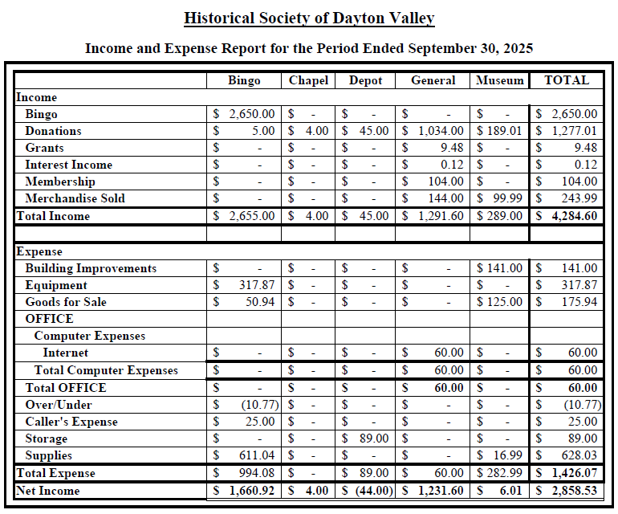
Attachment 1
Treasurer’s Reports (Page 2 of 3)

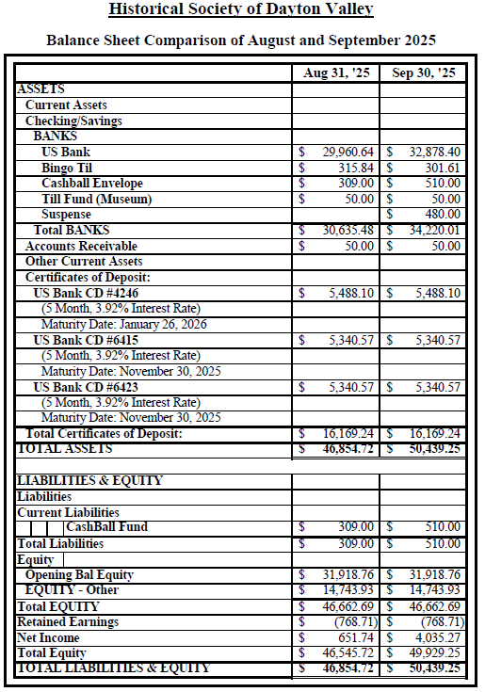

Attachment 1
Treasurer’s Reports (Page 3 of 3)

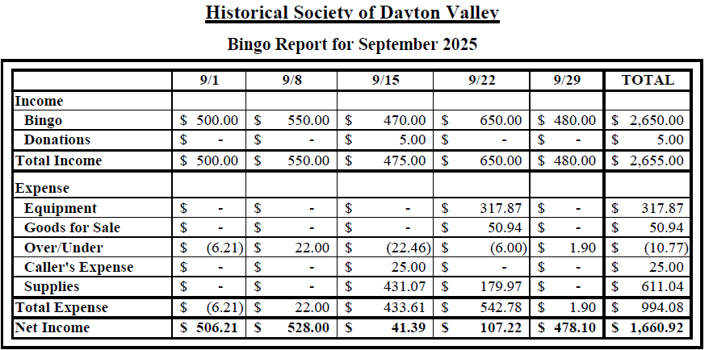
Attachment 2
Action Item List

# | Status | Month | Who | Item
53 | Open | Apr-24 | Laura | Investigate a grant to get museum paintings restored.  Jun-24: It was suggested Laura contact the Nevada Arts Council.  Jul-24: Gloria found a YouTube video on how to clean old paintings. She will send it to Becca. It was also suggested we contact UNR to see if a student might clean our paintings as training. Becca may try to clean a painting if necessary but we need to identify a low-risk painting to start with.  Aug-24: Opened new action item 104 to separately track contacting NV Arts Council.  Sep-24: Becca researched methods and agreed to try on a small, least important painting (to be id'ed by Laura). She will purchase her own supplies (~$250) and if successful, will ask to be reimbursed.  Aug-25: Ruth Small has volunteered to repair paintings. Vicki suggested we talk with Ruth and Becca about the work before implemented.  Sep-25: Ruth has decided that soap and water is not a good idea. Becca is willing to donate the supplies she has. Laura is to coordinate this effort.
Action Item List (Cont’)

# | Status | Month | Who | Item
61 | Closed Oct-25 | May-24 | Glenn | Need to try to get new carpet for the museum at both the front office and the entry room. Perhaps a remnant or donation.  Jun-24: Gloria to measure the space.  Jul-24: Vicki has a bunch of people working on moving stuff for the chapel. She will ask them to measure it and work at getting carpet.  Aug-24: Measurements taken. Vicki to contact Atkins  Oct-24: Stony has some carpet but needs to see if it is enough.  Nov-24: The carpet is big enough. It is indoor/outdoor type. Stony and Glenn to arrange a work day after the museum is closed for the winter.  Mar-24: Laura will get the carpet to the museum. Glenn will lay the carpet using tacks (not glue).  Apr-25: Glenn still waiting on carpet.  May-25: The proposed carpet is not attractive. Laura will check with Atkins for what they have. Glenn will investigate what is currently in the museum.  Jul-25: Office needs carpet worse than entry room but ideally would like to replace both. Glenn will see what local stores have available.  Sep-25: The new carpet has arrived. Glenn and Dave will install it on Saturday.
78 | Open | Jun-24 | Stony/Laura | Add security to JohnD’s barn/shop.  Jul-24: Linda had an idea on security lights and camera which are motion activated. Stony would put it inside the shop. Motion passed for Linda to buy this. Stony agreed to install it.  Aug-24: Equipment has been purchased and is awaiting installation.  Oct-24: In process, but camera needs to be located  Jan-25: Stony has located the camera and will do the install.  Apr-25: Email reminder to be sent to Laura regarding Stony’s installation of camera at John D’s Barn/Shop.  May-25: Becca will remind Laura to remind Stony.  Jun-25: Stony is missing a component but is working on it.
Action Item List (Cont’)

# | Status | Month | Who | Item
102 | Open | Aug-24 | Linda | Finish the paperwork for the transfer of the Station Masters House. Linda has a contact to research the process. (Separated from Action Item 5)  Sep-24: The attorney is Steve Landuyt who is a member. Linda to ping him.  Nov-24: Linda has pinged him but no response yet.  Feb-25: Steve is working on it.  Mar-25: No reply from Steve yet.  Apr-25: Linda has not heard back from Steve Landuyt. It was recommended she find a real estate attorney and pay for their advice.  May-25: Linda is reaching out in a couple of directions.  Jun-25: The new Comstock Commissioner has legal training but isn't certified. She will review the papers once Linda puts them together.  Jul-25: Linda received very general feedback and is considering the next steps.  Sep-25: Linda will contact a lawyer and pay them to do the paperwork. Motion: Authorize Linda to spend up to $1000 to get a lawyer involved. (Motion: Dan; Second: Glenn) Motion Passed
156 | Open | Feb-25 | Glenn/Becca | Learn Past Perfect and its capabilities, especially in regards to an inventory system for items sold at the museum. (Spawned by action item 66.)
157 | Open | Feb-25 | Dan/Glenn | There is a nice display cabinet in the speeder shed that needs to be moved either to the chapel or the storage shed.  Feb-25: Dan, Glenn and Gene will move it.  May-25: It should be moved to the chapel.  Sep-25: It should be moved to the carport at the depot instead due to space.
Action Item List (Cont’)

# | Status | Month | Who | Item
163 | Open | Feb-25 | Dan / Linda / Glenn | Investigate getting a QR code for all our sites.  May-25: Dan is working at making the walking tour file smaller. Once on the website, the QR codes become easy. The map can have clickable locations as well. Voice files will be created in addition to the text.  Jun-25: Linda will send the file of just the map text to Dan.  Sep-25: File has been sent and Dan is working on it.  Oct-25: Linda or Glenn need to make the map file size smaller.
166 | Open | Feb-25 | Dan | Assemble old hard copies of Laura's Reflections.  Mar-25: Laura has them and needs to get them to Dan to be scanned.  May-25: They are already on Newspapers.com which required a subscription; however, they are poorly scanned. Dan to talk to a librarian at the State Archives for ideas/methods.  Sep-25: Digital copies are at the UNR library but access has been an issue. Perhaps the digital collection librarian can help.  Oct-25: Dan to check if anyone can access these from UNR. If so, the link can be added to the website and this action item can be closed.
176 | Open | Apr-25 | Laura | Restore ledger kept by Dr. Hazlett  Jun-25: The ledger is going to Joe Curtis to be restored.  Sep-25: Joe can't do this so Laura is going to photograph the ledger then see if it can be scanned. She will talk to Kari about it.
179 | Open | Apr-25 | Glenn | Need to verify email is possible from Past Perfect to members; send out email and ask members to respond on receipt.  Sep-25: Glenn has struggled to make Outlook work with PP. Perhaps try Thunderbird instead?
Action Item List (Cont’)

# | Status | Month | Who | Item
183 | Open | May-25 | Glenn / Vicki / Dave / Dan / Stony | Propose a plan for landscaping at the Chapel.  Jul-25: Waiting on Design Standards Committee to make a recommendation  Sep-25: Glenn has submitted a plan to the committee  Oct-25: Need to talk to Shelly Smith about a certificate of compliance with the Comstock Standards. Glenn is to redraw the plan to remove the artifical turf. Someone on the Design Standards Committee will call a meeting.
184 | Open | May-25 | Stony/ Glenn/Dave/Vicki | New committee created to make recommendation to board on put up the entry way to the chapel  Jul-25: Waiting on the Chapel Committee to get with the Design Standards Committee to make a recommendation
193 | Open | May-25 | Linda/Dan/ Becca/Glenn/ Dave/Vicki/ Laura | Move needed files on the museum PC from "Old Computer" file to appropriate place.  Aug 25: Linda still needs to find the time to use AnyDesk on the Museum computer.
198 | Open | Jun-25 | Laura / Glenn | Laura would like another small cabinet for the museum to put where the piano was. She will send out desired dimensions.  Oct-25: Glenn has the measurements.
200 | Open | Jun-25 | Dan | Create a QR code to post at the museum that sends people to the membership page of the website. Becca to send him the page link once she re-enables the online memberships.  Jul-25: Becca has re-enabled online memberships and sent link to Dan the day before the BoD meeting  Sep-25: Becca is to resend the email
206 | Open | Jun-25 | Linda / Vicki | Prepare annual report owed to the County on planned maintenance, repairs, or improvements.  Aug 25: Glenn submitted a list of items to Linda. Vicki needs to send her input to Linda.
213 | Closed Oct-25 | Jul-25 | Glenn/Stony | Can we get the dirt pile behind the chapel moved and rent that space for parking during DVD?  Aug 25: Get with Stony to use his tractor and move dirt behind Fire House.
# | Status | Month | Who | Item
214 | Open | Jul-25 | Glenn / Margie / Becca | Recommend the newsletter include a list of memorial notifications and a “welcome” to new members. Recommend each newsletter include an article of “Member Highlight”, interviewing one member.  Oct-25: Becca will send out a list of potential interview questions.
215 | Closed Oct-25 | Jul-25 | Glenn / Margie | Recommend each newsletter include an article of “Member Highlight”, interviewing one member  Oct-25: Reccommended this be combined with Action Item 214.
217 | Open | Aug-25 | Dave | Get new museum keys for all who request one.
220 | Closed Oct-25 | Aug-25 | ? | Need to form a committee to manage the Chapel, and select a chairman.  Oct-25: Vicki agreed to be chairman.
223 | Closed Oct-25 | Sep-25 | Becca | Create a sign out sheet in the museum for items borrowed or taken home to work on.
225 | Open | Sep-25 | Laura | Speak with Janette about getting keys to the community center
226 | Closed Oct-25 | Sep-25 | Becca | Schedule a meeting to plan the Historic Hayride and record notes from the meeting
228 | Open | Sep-25 | Glenn/Becca | Review transactions in the PayPal account
229 | Closed Oct-25 | Sep-25 | Glenn | Renew our current insurance.
231 | Open | Oct-25 | Vicki | Need to remove Gloria from the alarm call list for the museum. Vicki will find out how we change it.
232 | Open | Oct-25 | Becca | Send out a notice to the membership that since no office was contested, there will be no voting. It will announce the board members and include that we have an opening for another Director if anyone is interested.
233 | Open | Oct-25 | Vicki | See if Margie is willing to co-chair the holiday party, and see if we can get the same chef as last year. Also need to determine the date based on chef and community center availability.
235 | Open | Oct-25 | Linda | Submit the intent to apply for CCCHP grant for a wheelchair lift at the museum.
236 | Open | Oct-25 | Dan | Assist Glenn with reviewing invoices related to the closed meeting topic.
Action Item List (Cont’)
Addition to the Pending Actions

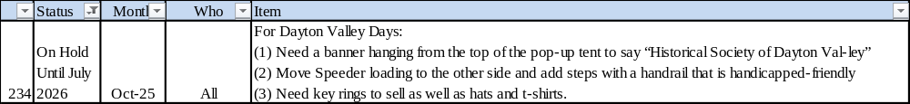
Attachment 3
Planning Calendar

Month | Activity
Jan | Plan for Museum Opening
Jan | Collect information of who volunteered the prior year
Jan | Plan the 4th grade school program
Jan | Select date for Holiday party in December and book a caterer
March | Opening of Museum
March | Mail invitations for Volunteer Appreciation Luncheon
March | Prepare and file IRS taxes
April | Hold Volunteer Appreciation Luncheon
April-May | Submit application for DVD booth
May | Conduct 4th grade school program
May | Start work on membership renewals due June 30th
July | Plan for Dayton Valley Days
August | Notify membership about elections procedures and nominations
August | Plan for Haunted Hayride
Sept | Dayton Valley Days
Sept | Open nominations for elections
Sept | Start reviewing insurance renewals
Oct | Mail out ballots for elections
Oct | Hold Historic Hayride
Oct | Board to discuss any awards to be given
Oct | Plan for Holiday Party
Nov | Complete elections vote counting
Nov | Send out invitations for Holiday Party
Nov | Ensure community center is reserved for next year's BoD mtgs and monthly membership mtgs
Nov | Board to vote on any awards to be given
Dec | Apply for bingo permit for next year
Dec | Holiday Party

