historical society of dayton valley
November 12, 2025
1:00 pm – At DVCC

Board meetings are for Board Business. Members are welcome to attend and can comment if invited to do so by the chair or after the board has finished their discussion, but remarks should be limited so that the Board agenda can be completed. By advanced request, a member may ask to be placed on the Board Agenda to offer specific information or request a specific action.

CALL MEETING TO ORDER – President, Linda Clements, called BoD meeting to order at 1:07 pm.

BOARD MEMBERS PRESENT:

Position | Name | Present (√)
President | Linda Clements | √
Vice President | Dan South | √
Secretary | Becca Krach | √
Treasurer | Glenn Sidener | √
Director 1 | Dave Schmitt | √
Director 2 | Vicki Kinney | √
Director 3
HSDV Historian (Ex Officio) | Laura Tennant | √
Guest

APPROVAL OF AGENDA –
- Agenda for November 12, 2025 was approved. (Motion: Becca, Second: Laura) – Motion Passed

APPROVAL OF MINUTES –
- Minutes for October 8, 2025 were approved. (Motion: Becca, Second: Glenn) – Motion Passed

TREASURER’S REPORT –
- Glenn presented the Balance Sheet, Profit and Loss, and Bingo Financial Reports for October 2025. (See Attachment 1).
- Motion: Approve the Treasurer’s Reports. (Motion: Becca, Second: Vicki) -- Motion Passed

CORRESPONDENCE – Communications received:
- Received various monthly mailings from museums associations
- Received thank you letter for the donating the school bell to Fort Churchill. (See Attachment 4)

PRESIDENT COMMENTS:
- The Beans have notified us that they will be sending us a donation.
- Linda purchased an original letter from Governor Nye requesting funds to cover the cost of supplying troops to Dayton to quell a riot in August, 1864. She will donate it to the museum. . (See Attachment 5)

BOARD MEMBER COMMENTS:
- None

OLD BUSINESS
- Reviewing Action Item List – Everyone (See Attachment 2)
  - Action Item 230: Motion: Approve Glenn to spend up to $200 to install LEDS with a remote control. (Motion: Becca, Second: Laura) -- Motion Passed
- Report: Depot Committee – Rebuild status – Stony Tennant et al.
  - Rolling scale, likely from our depot, likely SP-era – Linda
    - There is a person who wants to donate it to us but it is located in Idaho. We would have to pay for shipping or go get it. The board agrees it is desirable for us to have it. Vicki will talk to Gene about picking it up.
  - Reconstruction will be starting soon, with Dave Bates Construction. They are willing to work with Stony. Current estimate is completion by June 1st.
- After-action Report Historic Hayride – Becca (See Attachment 3)
  - Attendance: 300-350 people (had to run an extra hour)
  - Volunteers: 48 people; approx.. 400 man-hours
  - Under Budget
    - Budget: $1,700; Actuals: $640.27
    - Donated straw bales and refreshments saved approx.. $700
  - Captured 24 comments, suggestions, and notes for next year
- Holiday Awards party, Sat., Dec. 13, Community Center - Vicki
  - “Save the Date” notice was sent out.
  - The menu chosen was the chicken option at $32.50, with reduction if we get a large turnout.
  - Motion: Charge attendees $25 per person for members and their guests, and $32.50 for non-members. (Motion: Becca; Second: Glenn) – Motion Passed.
  - Invites will go out before Thanksgiving. Vicki will send info to Becca for posting on the website.
- Update on Main Street Nevada project – Dan
  - By-laws have been completed.
  - Applied for “America 250” grant for $1,000 to clean up downtown. Hopefully they will hear by the end of the month.

NEW BUSINESS
- Award nominations and decisions - Board
  - Previously Nominated for Laura Tennant award:
    - Carol Bauer for Laura Tennant award
    - Pam Abercrombie for Laura Tennant award
    - Jim Wetzel for Laura Tennant award
  - Additional Nominations
    - Lisa Smith for Joe Ricci, Sr. Posthumous Award
      - This award is only for people who were not honored during their lifetime. Lisa was given Laura Tennant in 2022, so her nomination was withdrawn,
    - Katrina Hedlesky for Laura Tennant Award
  - Motion: Approve Carol Bauer and Katrina Hedlesky for the Laura Tennant. (Motion: Becca, Second: Dave) -- Motion Passed
  - Becca to send both the awardees complimentary invitations to attend the holiday party.
- Repair of shed at museum – Glenn
  - Everything in the shed will be moved to JD’s Barn.
  - Next, Glenn will prop up the failing wall for now.
  - Then, Glenn will get with Stony to plan the permanent fix.
- Consideration of appointment of Board member – Vicki
  - Johnye Saylor has expressed interest in joining the board.
  - Motion: Accept Johnye as a director-at-large for 1 year term (Motion: Vicki; Second: Laura) – Motion Passed
  - Becca to contact her and work at adding her to the board list on the website and HSDV email, etc.
- Purchase of vacuum cleaner and ladder for museum – Vicki
  - Motion: Authorize Vicki to spend up to $500 for an indoor 8’ ladder and a new small vacuum cleaner for the museum. (Motion: Becca; Second: Glenn) – Motion Passed
- Refreshments for November lecture – Who?
  - Vicki has people coordinated to do this.
  - Cynthia Deis and Dave Grieco might be willing to head up a refreshment committee.
- Robert Stolting of Fernley requests advice on forming historical society, meet Nov. 23? – Linda
  - Laura and Linda to meet with him at the museum, and others are welcome to be there as well.
- Nominating Old Town buildings for State Historic Register – Linda and Becca
  - The top priority is the museum. It will used to work through the process.
  - Other buildings to eventually be nominated include: Firehouse/Jail, Chapel, Odeon, Community Center, Depot (after rebuilt), Camel Barn
- Inventory of donated physical items, esp. directed donations – Linda
  - Stony has donated a lot of items but has not filled out paperwork. We need to find, identify, and document these things so a record of their intended use can be created.
  - We should look at all the items in the firehouse basement, railroad sheds, and storage units to see what needs to be documented. We only need to document items that came with conditions, such as this can be used only for the railroad.
  - We need people to take the lead on each building looking at what is there.
    - RR – Linda
    - Firehouse – Dave
    - Chapel -- Glenn
- Possibly move daytonnvhistory.com to our Hostinger account – Linda and Becca
  - Domain registration will be $18/yr. It is not clear if hosting will cost us anything as a mirror site.
  - Motion: Authorize Becca to spend up to $200 to get the domain name moved under HSDV control and established as a mirror site. (Motion: Becca; Second: Dan) – Motion Passed
- Gretchen Arndt’s will wanted Jake (her dog) interred in “Gretchen’s Garden” in a mall concrete box. Motion: Invite Jake to the garden. (Motion: Dan, Second: Linda) – Motion Passed

HISTORY MOMENT (Laura):
- Deferred

UPCOMING ABSENCES:

Who | When | Comments
Dan | Dec 5 – Dec 8
Becca | Jan 2 – Jan 12

NEXT LECTURE: “Depots of the Virginia & Truckee Railroad and Carson & Colorado Railroad,” Jean-Guy Dube’, Thursday, November 20, 7 pm, Community Center

NEXT BOARD MEETING: Wednesday, January 14, 2026

ADJOURN: Meeting formally adjourned at 4:00 pm.

Respectfully submitted: Becca Krach, Secretary
Approved by the Board: ___

BOARD OF DIRECTORS
President, Linda Clements 775-246-0505 – Vice President, Dan South 775-220-8021
Secretary, Becca Krach 443-799-4827 – Treasurer, Glenn Sidener 775-671-4205
Directors Vicki Kinney 775-750-7915, Dave Schmitt 408-802-8997
Dayton Historian & Curator – Laura Tennant 775-246-3256
Attachment 1
Treasurer’s Reports (Page 1 of 3)

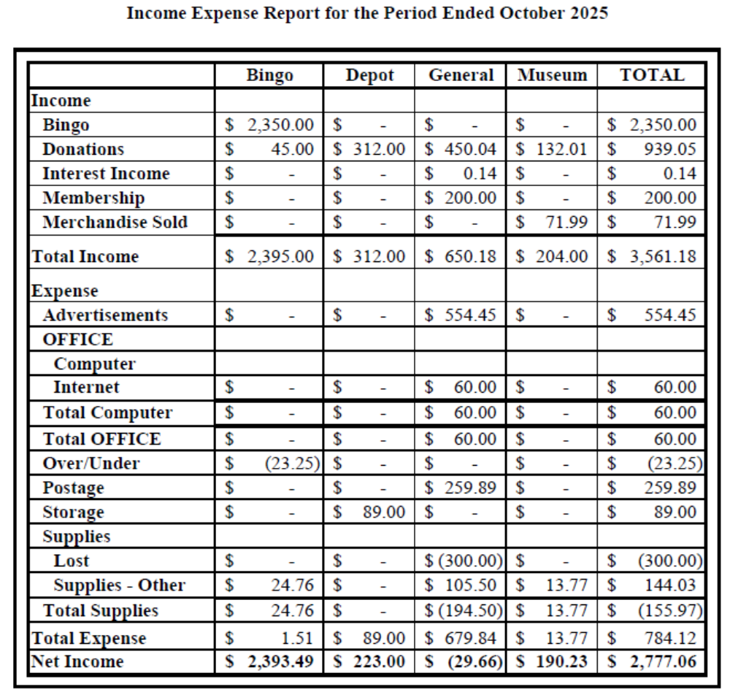
Attachment 1
Treasurer’s Reports (Page 2 of 3)

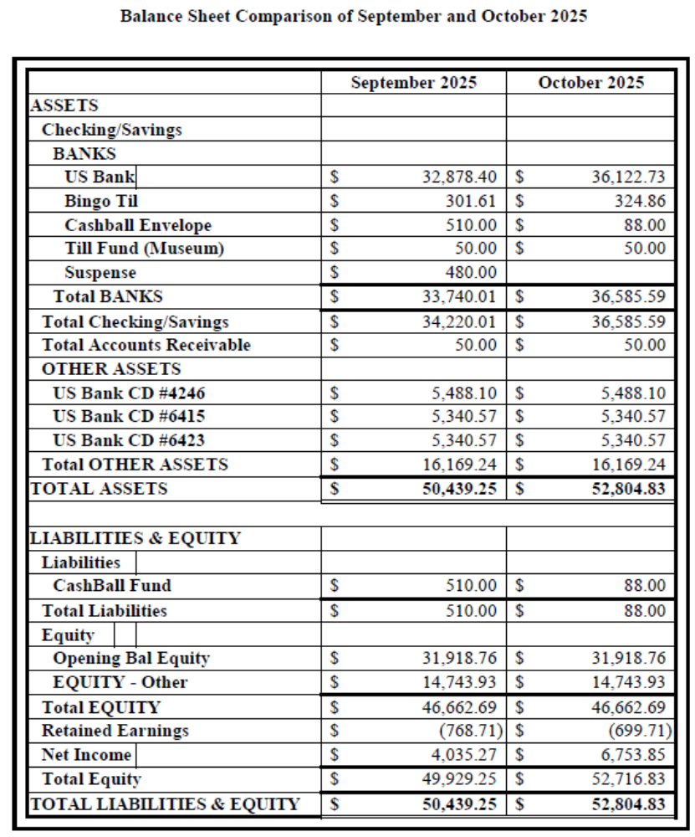

Attachment 1
Treasurer’s Reports (Page 3 of 3)

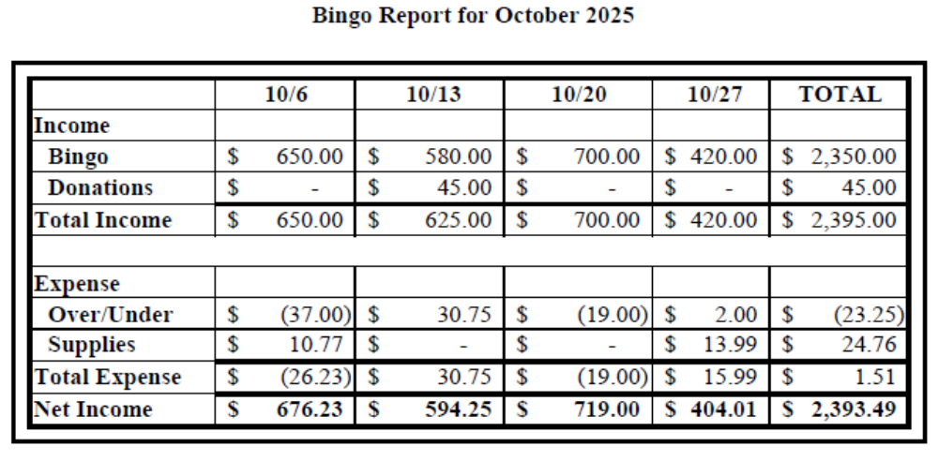

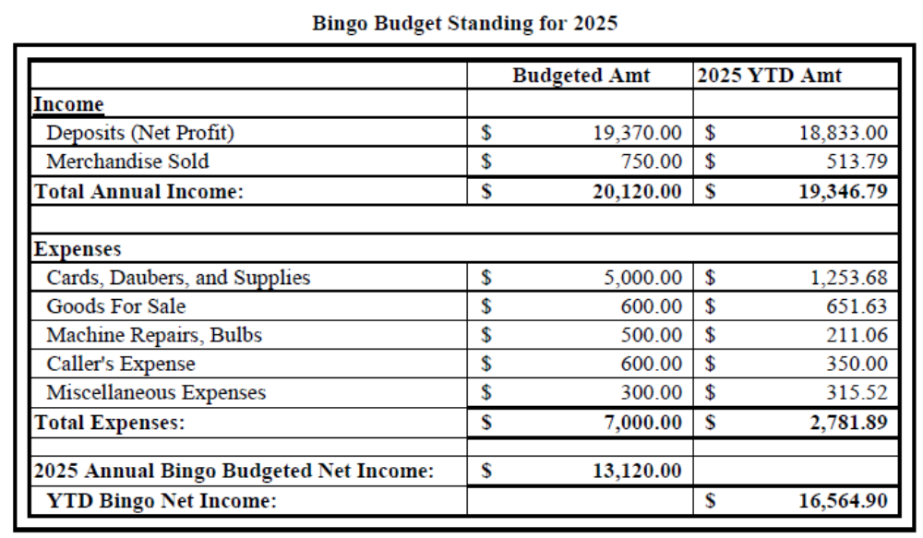
Attachment 2
Action Item List

# | Status | Month | Who | Item
53 | Closed Nov-25 | Apr-24 | Laura | Investigate a grant to get museum paintings restored.  Jun-24: It was suggested Laura contact the Nevada Arts Council.  Jul-24: Gloria found a YouTube video on how to clean old paintings. She will send it to Becca. It was also suggested we contact UNR to see if a student might clean our paintings as training. Becca may try to clean a painting if necessary but we need to identify a low-risk painting to start with.  Aug-24: Opened new action item 104 to separately track contacting NV Arts Council.  Sep-24: Becca researched methods and agreed to try on a small, least important painting (to be id'ed by Laura). She will purchase her own supplies (~$250) and if successful, will ask to be reimbursed.  Aug-25: Ruth Small has volunteered to repair paintings. Vicki suggested we talk with Ruth and Becca about the work before implemented.  Sep-25: Ruth has decided that soap and water is not a good idea. Becca is willing to donate the supplies she has. Laura is to coordinate this effort.  Nov-25: Ruth has cleaned all the paintings.
78 | Open | Jun-24 | Stony/Laura | Add security to JohnD’s barn/shop.  Jul-24: Linda had an idea on security lights and camera which are motion activated. Stony would put it inside the shop. Motion passed for Linda to buy this. Stony agreed to install it.  Aug-24: Equipment has been purchased and is awaiting installation.  Oct-24: In process, but camera needs to be located  Jan-25: Stony has located the camera and will do the install.  Apr-25: Email reminder to be sent to Laura regarding Stony’s installation of camera at John D’s Barn/Shop.  May-25: Becca will remind Laura to remind Stony.  Jun-25: Stony is missing a component but is working on it.
Attachment 2
Action Item List (Cont’)

# | Status | Month |  | Who |  | Item
102 | Open | Aug-24 | Linda |  | Finish the paperwork for the transfer of the Station Masters House. Linda has a contact to research the process. (Separated from Action Item 5)  Sep-24: The attorney is Steve Landuyt who is a member. Linda to ping him.  Nov-24: Linda has pinged him but no response yet.  Feb-25: Steve is working on it.  Mar-25: No reply from Steve yet.  Apr-25: Linda has not heard back from Steve Landuyt. It was recommended she find a real estate attorney and pay for their advice.  May-25: Linda is reaching out in a couple of directions.  Jun-25: The new Comstock Commissioner has legal training but isn't certified. She will review the papers once Linda puts them together.  Jul-25: Linda received very general feedback and is considering the next steps.  Sep-25: Linda will contact a lawyer and pay them to do the paperwork. Motion: Authorize Linda to spend up to $1000 to get a lawyer involved. (Motion: Dan; Second: Glenn) Motion Passed
157 | Open | Feb-25 | Dan/Glenn |  | There is a nice display cabinet in the speeder shed that needs to be moved either to the chapel or the storage shed.  Feb-25: Dan, Glenn and Gene will move it.  May-25: It should be moved to the chapel.  Sep-25: It should be moved to the carport at the depot instead due to space.
Attachment 2
Action Item List (Cont’)

# | Status | Month |  | Who |  | Item
163 | Open | Feb-25 | Dan / Linda / Glenn |  | Investigate getting a QR code for all our sites.  May-25: Dan is working at making the walking tour file smaller. Once on the website, the QR codes become easy. The map can have clickable locations as well. Voice files will be created in addition to the text.  Jun-25: Linda will send the file of just the map text to Dan.  Sep-25: File has been sent and Dan is working on it.  Oct-25: Linda or Glenn need to make the map file size smaller.  Nov-25: Linda couldn't shrink the file size so she will send it to Glenn for him to try.
166 | Open | Feb-25 | Dan |  | Assemble old hard copies of Laura's Reflections.  Mar-25: Laura has them and needs to get them to Dan to be scanned.  May-25: They are already on Newspapers.com which required a subscription; however, they are poorly scanned. Dan to talk to a librarian at the State Archives for ideas/methods.  Sep-25: Digital copies are at the UNR library but access has been an issue. Perhaps the digital collection librarian can help.  Oct-25: Dan to check if anyone can access these from UNR. If so, the link can be added to the website and this action item can be closed.
176 | Open | Apr-25 | Laura |  | Restore ledger kept by Dr. Hazlett  Jun-25: The ledger is going to Joe Curtis to be restored.  Sep-25: Joe can't do this so Laura is going to photograph the ledger then see if it can be scanned. She will talk to Kari about it.
179 | Open | Apr-25 | Cheri M. / Glenn |  | Need to verify email is possible from Past Perfect to members; send out email and ask members to respond on receipt.  Sep-25: Glenn has struggled to make Outlook work with PP. Perhaps try Thunderbird instead?  Nov-25: Glenn has tried everything he can think of with no luck. Cheri will contact PP to try to fix it.
Attachment 2
Action Item List (Cont’)

# | Status | Month |  | Who |  | Item
183 | Open | May-25 | Glenn / Vicki / Dave / Dan / Stony |  | Propose a plan for landscaping at the Chapel.  Jul-25: Waiting on Design Standards Committee to make a recommendation  Sep-25: Glenn has submitted a plan to the committee  Oct-25: Need to talk to Shelly Smith about a certificate of compliance with the Comstock Standards. Glenn is to redraw the plan to remove the artificial turf. Someone on the Design Standards Committee will call a meeting.  Nov-25: Meeting will be on Friday to discuss the landscaping. Vicki spoke to Shelley about the Comstock Standards and they are ok with our general plans.
184 | Open | May-25 | Stony/ Glenn/Dave/Vicki |  | New committee created to make recommendation to board on put up the entry way to the chapel  Jul-25: Waiting on the Chapel Committee to get with the Design Standards Committee to make a recommendation  Nov-25: This will also be covered at the meeting on Friday.
191 | Open | May-25 | Vicki |  | Write an article for the newsletter regarding the school program.  Jul-25: Suggested for January Newsletter to perhaps inspire more people to take part.
193 | Open | May-25 | Linda/Dan/ Becca/Glenn/ Dave/Vicki/ Laura |  | Move needed files on the museum PC from "Old Computer" file to appropriate place.  Aug 25: Linda still needs to find the time to use AnyDesk on the Museum computer.
198 | Open | Jun-25 | Laura / Glenn |  | Laura would like another small cabinet for the museum to put where the piano was. She will send out desired dimensions.  Oct-25: Glenn has the measurements.  Nov-25: It is 34" wide x 16" deep

Attachment 2
Action Item List (Cont’)

# | Status | Month |  | Who |  | Item
200 | Closed Nov-25 | Jun-25 | Dan |  | Create a QR code to post at the museum that sends people to the membership page of the website. Becca to send him the page link once she re-enables the online memberships.  Jul-25: Becca has re-enabled online memberships and sent link to Dan the day before the BoD meeting  Sep-25: Becca is to resend the email  Nov-25: Dan has made a QR link that takes you to the donate button. He will talk to Kari about making some on weather-proof printing to add to our signs. We could also do audio files and make QR links to them but cell service is too spotty in Dayton.
206 | Open | Jun-25 | Linda / Vicki |  | Prepare annual report owed to the County on planned maintenance, repairs, or improvements.  Aug 25: Glenn submitted a list of items to Linda. Vicki needs to send her input to Linda.
214 | Open | Jul-25 | Glenn / Margie / Becca |  | Recommend the newsletter include a list of memorial notifications and a “welcome” to new members. Recommend each newsletter include an article of “Member Highlight”, interviewing one member.  Oct-25: Becca will send out a list of potential interview questions.
217 | Closed Nov-25 | Aug-25 | Dave |  | Get new museum keys for all who request one.
225 | Open | Sep-25 | Becca |  | Speak with Janette about getting keys to the community center
228 | Closed Nov-25 | Sep-25 | Glenn/Becca |  | Review transactions in the PayPal account
230 | Open | Sep-25 | Glenn |  | Add LED lights inside the museum cabinets which hold the charm bracelets and the Bertha Scott items. There should be a way to turn them on and off without getting into the cabinet.  Nov-25: Motion: Approve Glenn to spend up to $200 to install LEDS with a remote control. (Motion: Becca, Second: Laura) -- Motion Passed
231 | Open | Oct-25 | Vicki |  | Need to remove Gloria from the alarm call list for the museum. Vicki will find out how we change it.  Nov-25: Vicki removed Gloria and discovered that Johnye Saylor is on the list as well. Vicki will update the phone list to Vicki, Becca, and Glenn.
Attachment 2
Action Item List (Cont’)

# | Status | Month |  | Who |  | Item
232 | Closed Nov-25 | Oct-25 | Becca |  | Send out a notice to the membership that since no office was contested, there will be no voting. It will announce the board members and include that we have an opening for another Director if anyone is interested.
233 | Closed Nov-25 | Oct-25 | Vicki |  | See if Margie is willing to co-chair the holiday party, and see if we can get the same chef as last year. Also need to determine the date based on chef and community center availability.  Nov-25: Margie is the co-chair and the chef is set.
235 | Closed Nov-25 | Oct-25 | Linda |  | Submit the intent to apply for CCCHP grant for a wheelchair lift at the museum.
236 | Closed Nov-25 | Oct-25 | Dan |  | Assist Glenn with reviewing invoices related to the closed meeting topic.
238 | Open | Nov-25 | Linda |  | Apply for CCCHP funding for ADA modifications at museum
239 | Open | Nov-25 | Becca |  | Ensure community center is reserved for next year's BoD mtgs and monthly membership mtgs
240 | Open | Nov-25 | Glenn |  | Apply for bingo permit for next year
241 | Open | Nov-25 | Dan |  | Dan to talk to Kari about making some QR donate buttons on weather-proof printing to add to our signs.
242 | Open | Nov-25 | Vicki |  | Consider if she and Gene can go to Idaho to pick up rolling scale for the depot.
243 | Open | Nov-25 | Vicki / Margie / Becca |  | Send out invitations for the Holiday Party on Dec 13. Also get info to Becca to post on the website.
244 | Open | Nov-25 | Becca |  | Send Carol Bauer and Katrina Hedlesky complimentary invitations to the holiday party.
245 | Open | Nov-25 | Glenn |  | Move everything in the shed to JD's Barn while the shed is repaired. Prop up failing wall for now.
246 | Open | Nov-25 | Glenn / Stony |  | Determine permanent fix for wall in shed.

Attachment 2
Action Item List (Cont’)

# | Status | Month |  | Who |  | Item
247 | Open | Nov-25 | Becca |  | Contact Johnye Saylor and get her electronically set up as a board member on website and email.
248 | Open | Nov-25 | Vicki |  | Purchase 8' ladder and small vacuum cleaner for museum.
249 | Open | Nov-25 | Vicki |  | Check if Cynthia Deis and Dave Grieco are willing to head up a refreshment committee.
250 | Open | Nov-25 | Becca |  | Investigate process for getting the museum on the State Historic Register.
253 | Open | Nov-25 | Linda |  | Investigate if any items in the RR buildings should be documented as directed donations.
254 | Open | Nov-25 | Dave |  | Investigate if any items in the Firehouse/Jail should be documented as directed donations.
255 | Open | Nov-25 | Glenn |  | Investigate if any items in the Chapel should be documented as directed donations.
256 | Open | Nov-25 | Becca |  | Rehost the domain daytonnvhistory.com on our Hostinger account and establish it as a mirror site.
257 | Open | Nov-25 | Dan |  | Invite Gretchen Arndt's dog, Jake, to "Gretchen's Garden".
258 | Open | Nov-25 | Becca |  | Send condolence card to Nancy Sbragia regarding Joey's passing.
259 | Open | Nov-25 | Vicki |  | Check with NV Historic Society and Pat Neyland to see if there is an alternative product to PastPerfect.
260 | Open | Nov-25 | Vicki /Laura /Glenn |  | Determine how to display the binders in the museum.
261 | Open | Nov-25 | Glenn / Dan |  | Put together a plan for upgrading the overhead lighting in the museum.

Action Item List (Cont’)
Addition to the Aspirations List

# | Status | Month | Who | Item
251 | Open | Nov-25 | Becca | Consider getting Firehouse/Jail, Chapel, Odeon, Community Center, Depot (after rebuilt) and Camel Barn on the State Historic Register.
252 | Open | Nov-25 | Becca | Consider if any building from items 250 and 251 can be included on the National Historic Register.

Attachment 3
Haunted Hayride Report
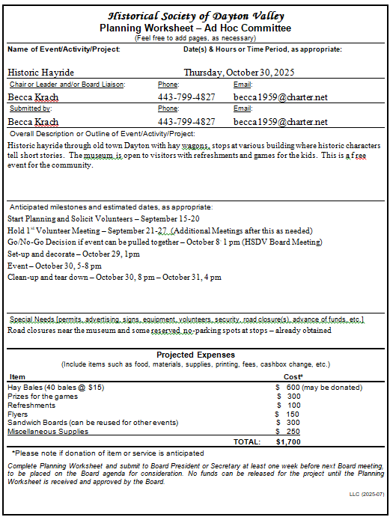

Attachment 3 (Cont’)
Haunted Hayride Report
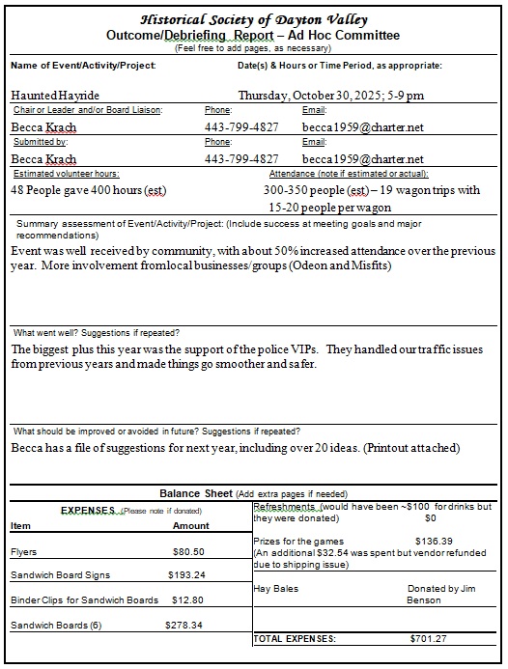
Attachment 3 (Cont’)
Haunted Hayride Report

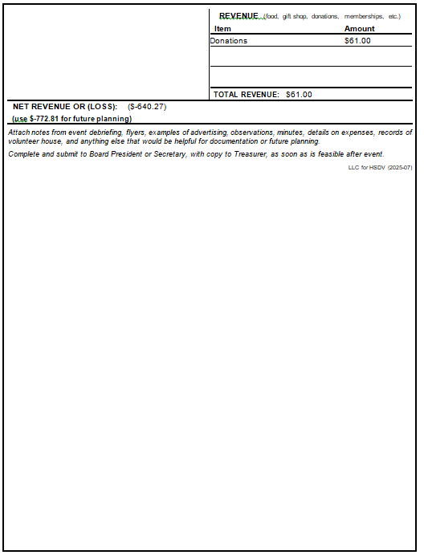
Attachment 3 (Cont’)
Haunted Hayride Report

Comments, Suggestions, and Notes for Next Year

- We used 24 straw bales for 3 trailers.
- Recommend keeping to roughly 12’ trailers. Any longer and they are hard to maneuver and hard for the rider at the back to hear the narrator.
- Recommend trying to have 1 more narrator than wagons, so they can hop off and have a break, then board the next wagon. Kind of musical chairs scheme.
- Re-evaluate timing so people don’t need to hang out at the museum so long on the day of the event. For example, maybe have cookies drop off at 4? If we need more, an emergence run to Smith’s can happen at 4:30?
- This year, we have a good amount of cookies donated and did not need to buy extras.
- Having mini-sandwiches from Port of Subs or something along those lines for the volunteers seemed to work well.
- Consider having 4 wagons instead of 3 to better accommodate the number of people. Perhaps have an extra stop to keep the 4 wagons spaced out thru town.
- Characters at stops need to keep things to 5 minutes. “Stories” about what people did are better received than a biography of their whole life.
- Need better scheme for narrators to signal drivers when to pull out of a stop. Perhaps small flashlights to blink at the driver?
- Maybe change up the games a bit or just have extra ones. What about “pick a duck” with a number on the bottom to indicate what prize they get. Maybe some type of basketball hoop toss or nerf football thrown thru a hanging loop.
- Keep local businesses involved so it is more of a community event.
- Add better lighting for loading/unloading the wagons, so they don’t need to use flashlights to see.
- Have an entertainer for the people in line, like a balloon maker, juggler, or magician.
- Have scavenger hunts available for the museum
- Consider having hot water for tea or decaf coffee in addition to regular coffee and cider.
- Remember to put a donation jar on the greeters’ table, as well as a pile of walking tour brochures and membership applications.
- Have an alternative means to making people stand in line. Maybe a sign in sheet or give out “chips” with a wagon number on them. This could also make it easier to keep track of how many people we have. Just have to be careful that we fill the wagons but not over fill them.
- Have a means to let drivers have a break. Maybe “back-up drivers” if the truck owners are willing to have someone else drive 1 round.
- Consider backrests for narrators like a stadium seat rest.
Attachment 3 (Cont’)
Attachment 3 (Cont’)
Haunted Hayride Report

Comments, Suggestions, and Notes for Next Year (cont’)

- Have clearer signage with directions for the event. The VIPs were asked many times about where the event was starting at.
- Need to start planning earlier next year. Too many things ended up being a rush – like the road closure permits.
- Flyers – Need more small ones and fewer posters and full size sheets.
- Get a 3-sided wrap-around tablecloth for the greeters’ table to cut the wind.
- Make sure everyone knows that the ending time (8 pm) is the cut-off for people to get in line – not the time of the last wagon. The actual event might run until 9 pm to get everyone through the hayride.

Attachment 4
Thank You Letter from Fort Churchill

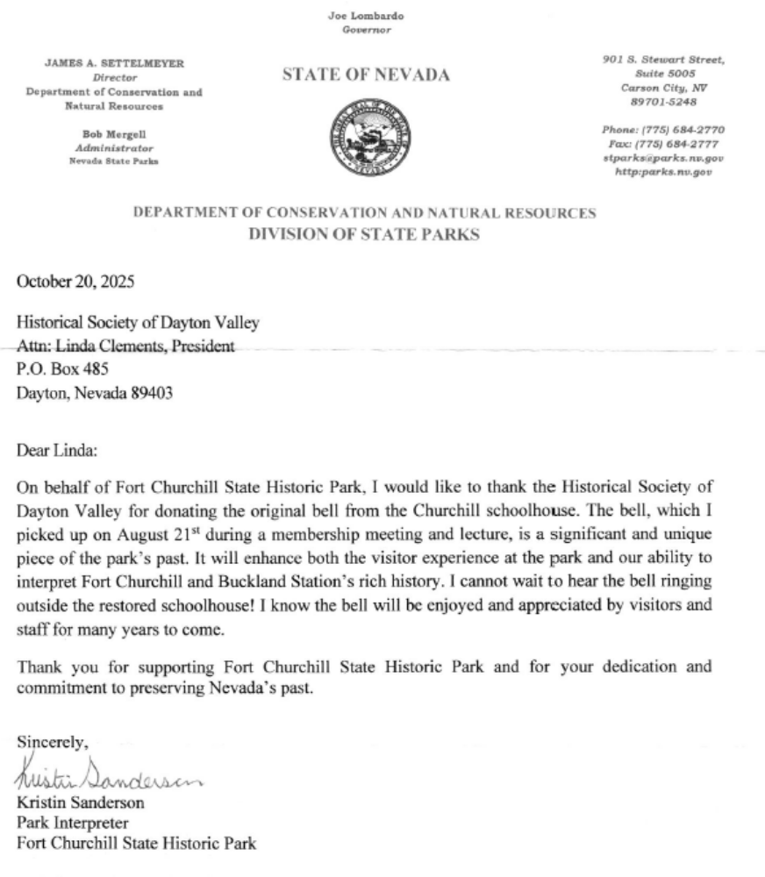
Attachment 5
Historic Letter Donated by Linda Clements

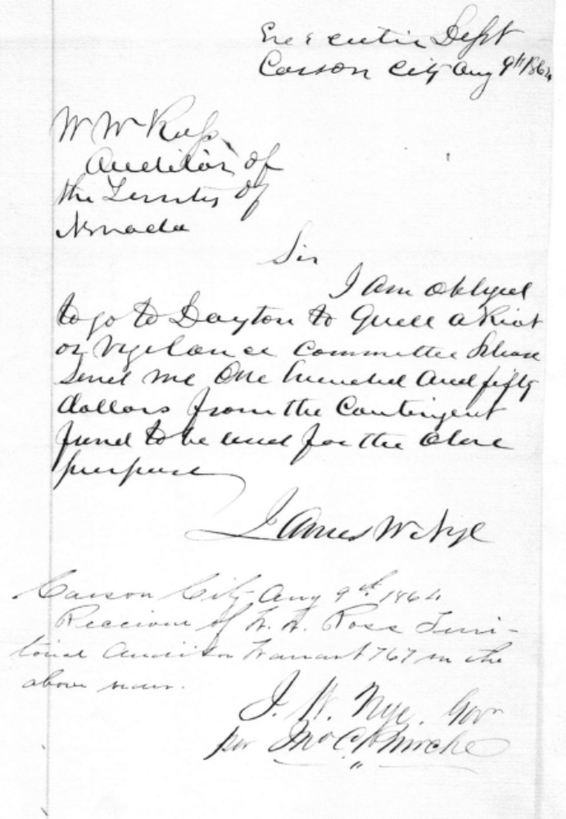
Attachment 6
Planning Calendar

Month | Activity
Jan | Plan for Museum Opening
Jan | Collect information of who volunteered the prior year
Jan | Plan the 4th grade school program
Jan | Select date for Holiday party in December and book a caterer
March | Opening of Museum
March | Mail invitations for Volunteer Appreciation Luncheon
March | Prepare and file IRS taxes
April | Hold Volunteer Appreciation Luncheon
April-May | Submit application for DVD booth
May | Conduct 4th grade school program
May | Start work on membership renewals due June 30th
July | Plan for Dayton Valley Days
August | Notify membership about elections procedures and nominations
August | Plan for Haunted Hayride
Sept | Dayton Valley Days
Sept | Open nominations for elections
Sept | Start reviewing insurance renewals
Oct | Mail out ballots for elections
Oct | Hold Historic Hayride
Oct | Board to discuss any awards to be given
Oct | Plan for Holiday Party
Nov | Complete elections vote counting
Nov | Send out invitations for Holiday Party
Nov | Ensure community center is reserved for next year's BoD mtgs and monthly membership mtgs
Nov | Board to vote on any awards to be given
Dec | Apply for bingo permit for next year
Dec | Holiday Party

